THIS IS A DECISION PAPER

TO: HARDIN COUNTY BOARD OF EDUCATION

FROM: TERESA MORGAN, SUPERINTENDENT

DATE: NOVEMBER 20, 2025

SUBJECT: APPROVAL OF CHANGE ORDER 11 FOR THE CHILD NUTRITION CONSTRUCTION PROJECT

ISSUE:
Change Order 11 is an increase of $1,043.11 for an additional dock concrete to increase the size of the chiller pad.

FACTS:

CO 11

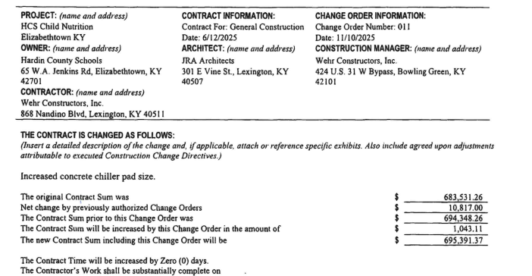

RECOMMENDATION
I RECOMMEND THE BOARD APPROVE CHANGE ORDER 11 FOR THE CHILD NUTRITION CONSTRUCTION PROJECT.

RECOMMENDED MOTION
I MOVE THE HARDIN COUNTY BOARD OF EDUCATION APPROVE CHANGE ORDER 11 FOR THE CHILD NUTRITION CONSTRUCTION PROJECT.

