Superintendent Report
October 22, 2025

Board Items
The Board Focus will be on our MTSS District Processes and presented by Mrs. Hicks.
- Consent Items: Most are the typical, but a few additional include:
  - Approve Jenny Hazeres to serve on the calendar committee.
  - Approve the KETS first offer of assistance for this school year. This is a matching offer and already accounted for in the budget.
  - Approve updated Special Education Procedures as recommended by Ms. Tara Wittrock
  - Asking permission to apply for the Greater Cincinnati Foundation grant which focuses on building bright futures for students. We feel we have a great plan for the $50,000 if awarded.
  - Approve an MOU to work with Sun Behavioral Health. There is no cost to the district for services and is an added layer of support for students and families.
- Action Items
  - Approve the pay applications as they relate to the construction projects. Ms. Hoover, Ms. Fardo, and I work closely with REH&A to verify the accuracy of these items.

October 20 Community Event
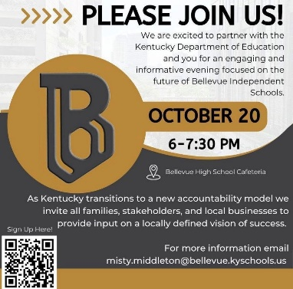
We are excited to work with Alexa Hardin from the Kentucky Department of Education to host a community event on October 20. This conversation will help inform our local accountability measures. The second series will be on Monday, November 17. I hope you are able to attend.

Construction
The recent rain and other obstacles have continued to push back completion dates of our project. Here is the latest update I have received regarding some bigger items.
GES: Some flooring did go down over Fall Break and more will go down during the other breaks (Thanksgiving and Christmas). The new gym flooring is complete, and we await the bleachers to be installed and the lobby to be finished and are hopeful to use the space the first of November.
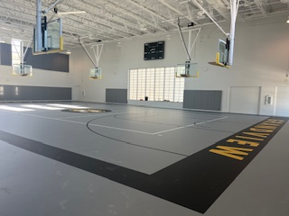

The metal panels were ordered incorrectly which is why there has been no movement. The playground is being completed in the next couple of weeks and we should see the retaining wall going in soon. The HVAC continues to provide some issues and we still do not have use of our elevator.

Stadium – The track surfacing is beginning to be applied and the asphalt for the tennis courts/parking area is being prepared. Work continues on the concession building while some work remains inside Ben Flora. Fencing is being installed and other items are being completed. Right now, we hope the tennis surface can be applied before the temperatures get too low.

EducateNKY
Attached to the superintendent report please see the information on the Read Ready Initiative promoted by EducateNKY. We will discuss more at our next work session.

Veterans Day
We will host a districtwide Veterans Day program on Veterans Day, which is Tuesday, November 11. This year’s event will begin at 1:30 and include all students in grades K-12. Mr. Jack Ondeck will be our honorary veteran speaker. Students will participate in the program as in order to honor and thank our veterans for their service, commitment, and bravery to our country and its citizens. Please join us if you are available.

One-to-One Reading/Tigers Read/ Adopt A Class
One to One Reading has begun with seven volunteers, Adopt-A-Class has begun with 4 teams working at GES, and Tigers Read will begin on November 7.

Food Service Stats
We were in school 21 days in the month of September. During that time there was a total monthly attendance of 10,151 students. There were 5,024 breakfasts served, 8,256 lunches served, and 1,054 after school snacks (GES only). I appreciate the hard work and dedication of our food service employees.

COSSBA
The COSSBA national conference is March 13-15, 2026 in Louisville, KY. Please let Renee or I know soon if you would like to attend. Registration is now open.

KSBA Annual Conference
Also, just to get this on your calendar the KSBA annual conference is February 20-22, 2026 at the Galt House in Louisville.

Upcoming Meetings/Events
- October 20 - Community “Forum” 6-7:30 BMHS Library
- October 22 - BOE meeting
- October 23-31, 2025: Red Ribbon Week - “Life is a Puzzle - Solve it Drug Free” - Spirit Week Oct 27-31
- October 23 – BEF Meeting 6:00, Military Appreciation night at the Football Game
- October 30 – Football Senior Night
- October 31 - Halloween GES Parade @ 1:45
- November 5 – Work Session
- November 11, 2025 - Veterans Day Observance in Ben Flora 1:00 for Veterans 1:30-2:30 Program
- November 17, 2025 - Community Forum Night 2
- November 19 – BOE Meeting
- November 20, 2025 - Black and Gold Night 6:00-7:30
- November 24-28 – No School

As always, please let me know if you have any questions or concerns.

Respectfully submitted,

Misty Middleton
Superintendent

