THIS IS A DECISION PAPER

TO: HARDIN COUNTY BOARD OF EDUCATION

FROM: TERESA MORGAN, SUPERINTENDENT

DATE: October 16, 2025

SUBJECT: APPROVAL OF BG 4’S FOR BID PACKAGES 260, 031, 040, 050, 096, 114, and 220 FOR THE CHHS RENOVATION PHASE 1 PROJECT

ISSUE:
Bid package 269 was for electrical, 031 was for concrete, 040 was for masonry, 050 was for structural steel, 096 was for flooring, 114 was for food service equipment, and 220 was for plumbing and HVAC.

FACTS:

BP 260
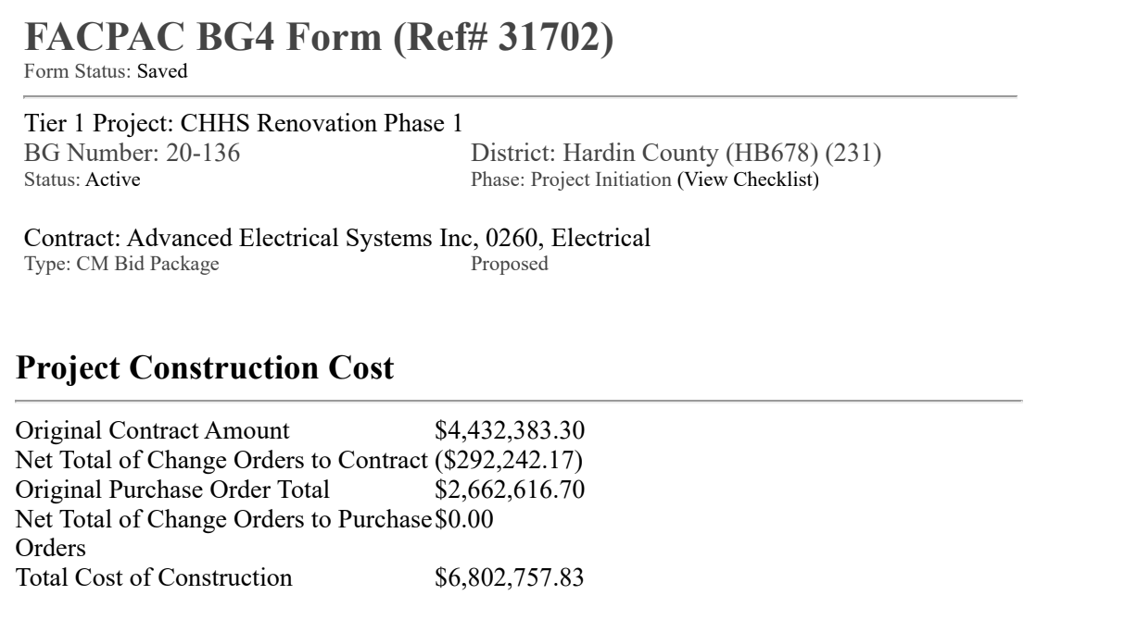
BP 031
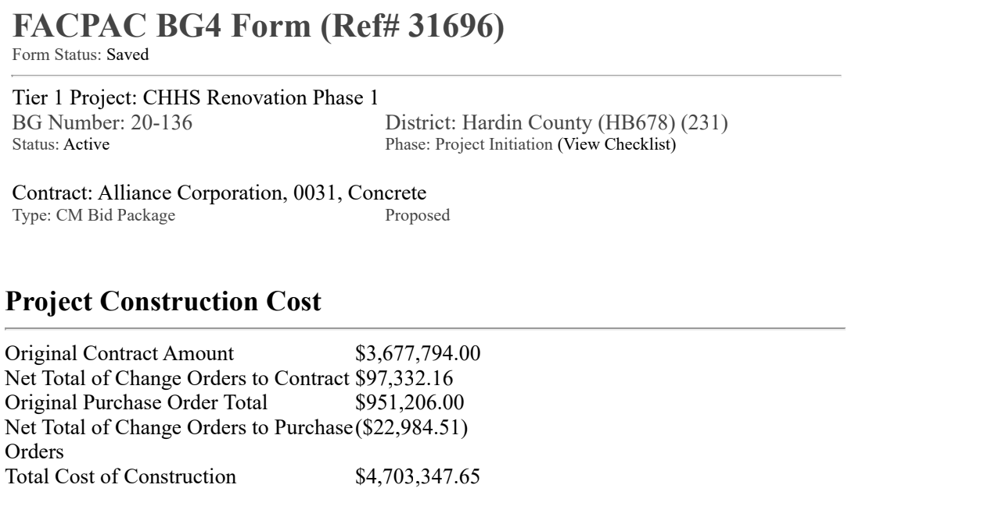

BP 040
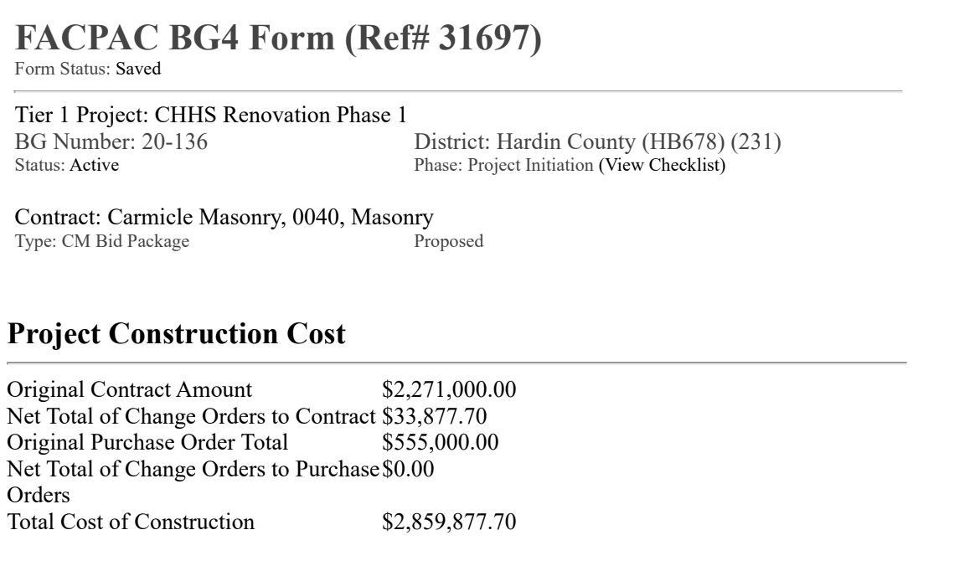

BP 050

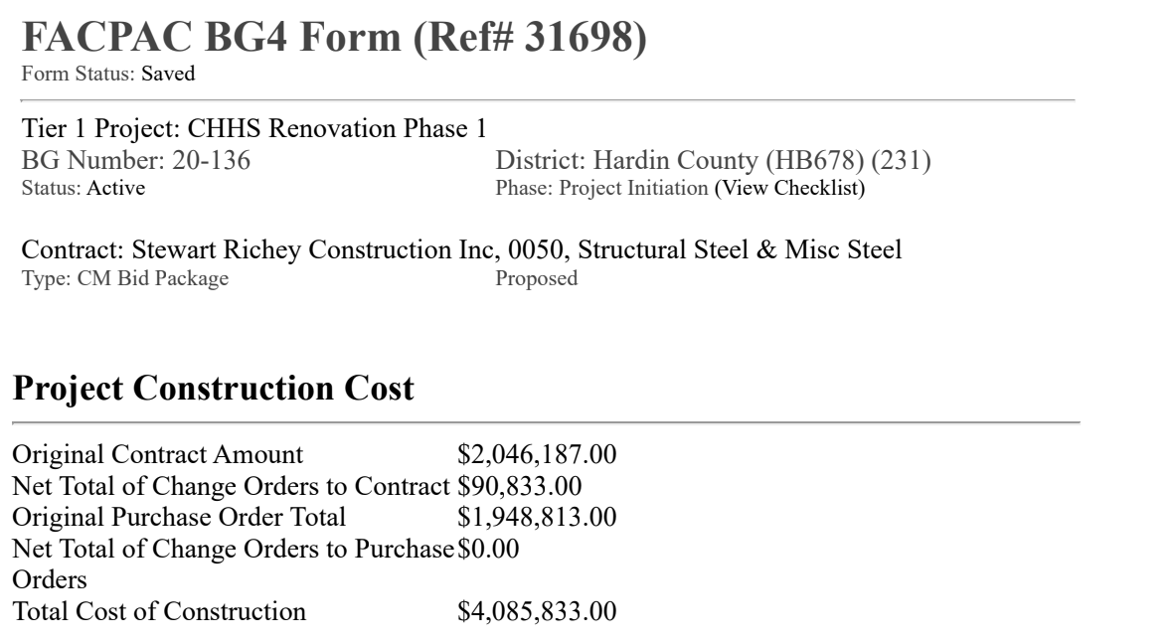
BP 096
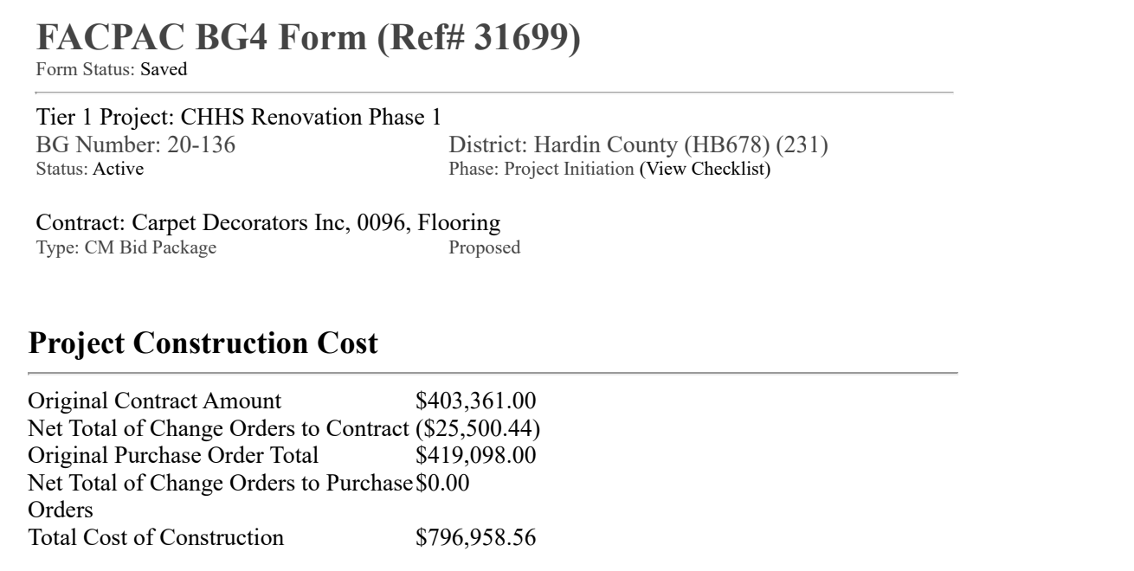

BP 114

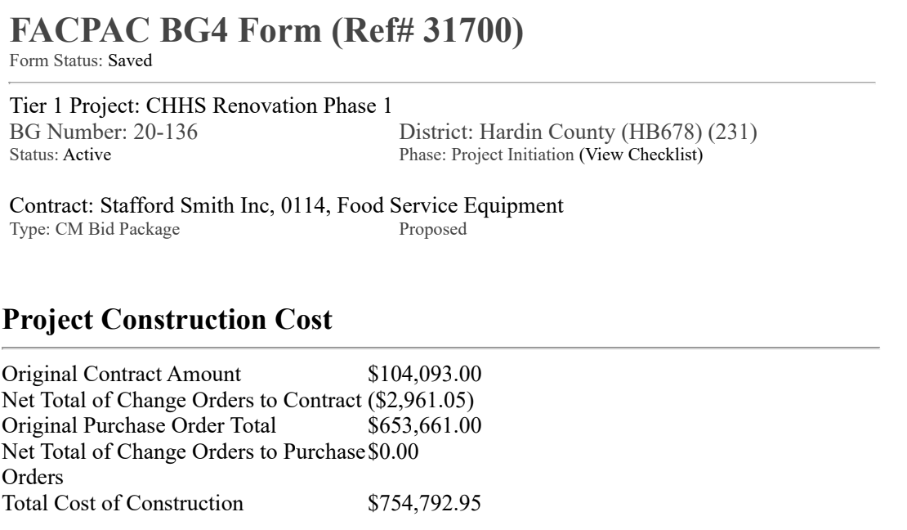

BP 220

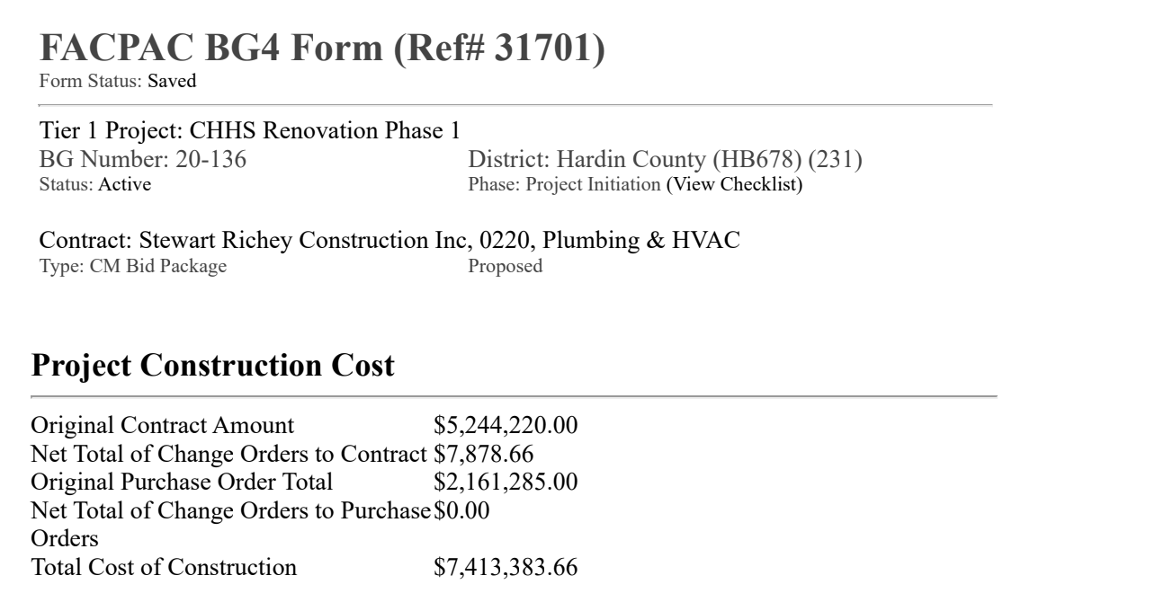

See attached BG 4’s

RECOMMENDATION
I RECOMMEND THE BOARD APPROVE BID PACKAGES 260, 031, 040, 050, 096, 114, and 220 FOR THE CHHS RENOVATION PHASE 1 PROJECT.

RECOMMENDED MOTION
I MOVE THE HARDIN COUNTY BOARD OF EDUCATION APPROVE BG 4’S FOR BID PACKAGES 260, 031, 040, 050, 096, 114, and 220 FOR THE CHHS RENOVATION PHASE 1 PROJECT.

