THIS IS A DECISION PAPER

TO: HARDIN COUNTY BOARD OF EDUCATION

FROM: TERESA MORGAN, SUPERINTENDENT

DATE: October 16, 2025

SUBJECT: APPROVAL OF CHANGE ORDER 11 FOR WEST HARDIN MIDDLE SCHOOL PROJECT

ISSUE:
Change Order 11 is an increase of $387,375 for additional geothermal casing required in the geothermal field.

FACTS:
CO 11

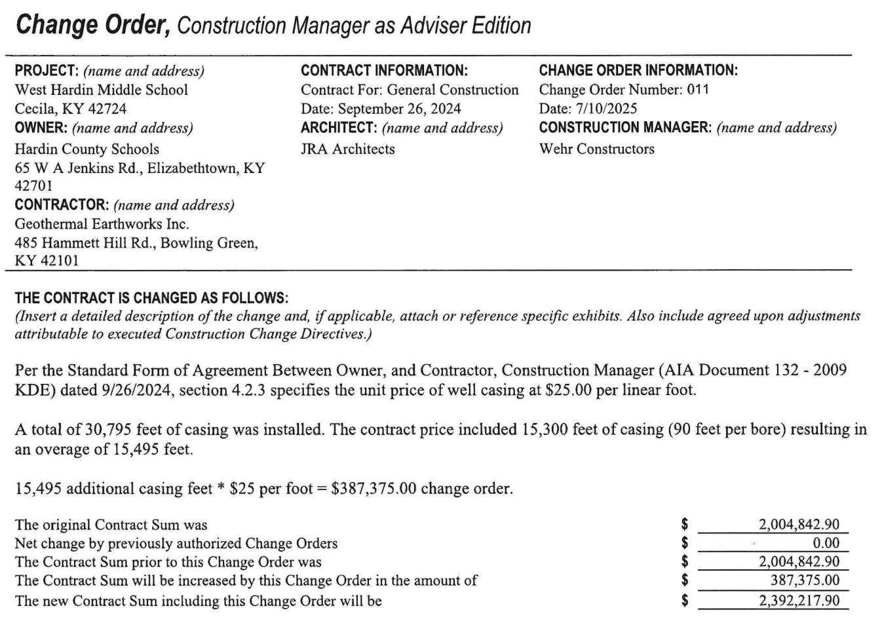

RECOMMENDATION
I RECOMMEND THE BOARD APPROVE CHANGE ORDER 11 FOR THE WEST HARDIN MIDDLE SCHOOL PROJECT.

RECOMMENDED MOTION
I MOVE THE HARDIN COUNTY BOARD OF EDUCATION APPROVE CHANGE ORDER 11 FOR THE WEST HARDIN MIDDLE SCHOOL PROJECT.

