THIS IS A DECISION PAPER

TO: HARDIN COUNTY BOARD OF EDUCATION

FROM: TERESA MORGAN, SUPERINTENDENT

DATE: October 16, 2025

SUBJECT: APPROVAL OF CHANGE ORDERS 8 AND 9 FOR THE CHILD NUTRITION CONSTRUCTION PROJECT

ISSUE:
Change Order 8 is an increase of $4,439.00 for an additional dock leveler, and Change Order 9 is a decrease of $1,011.94 for the removal of two light pole bases.

FACTS:

CO 8
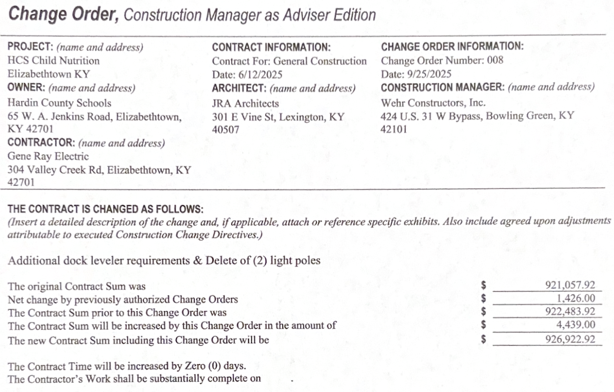

CO9
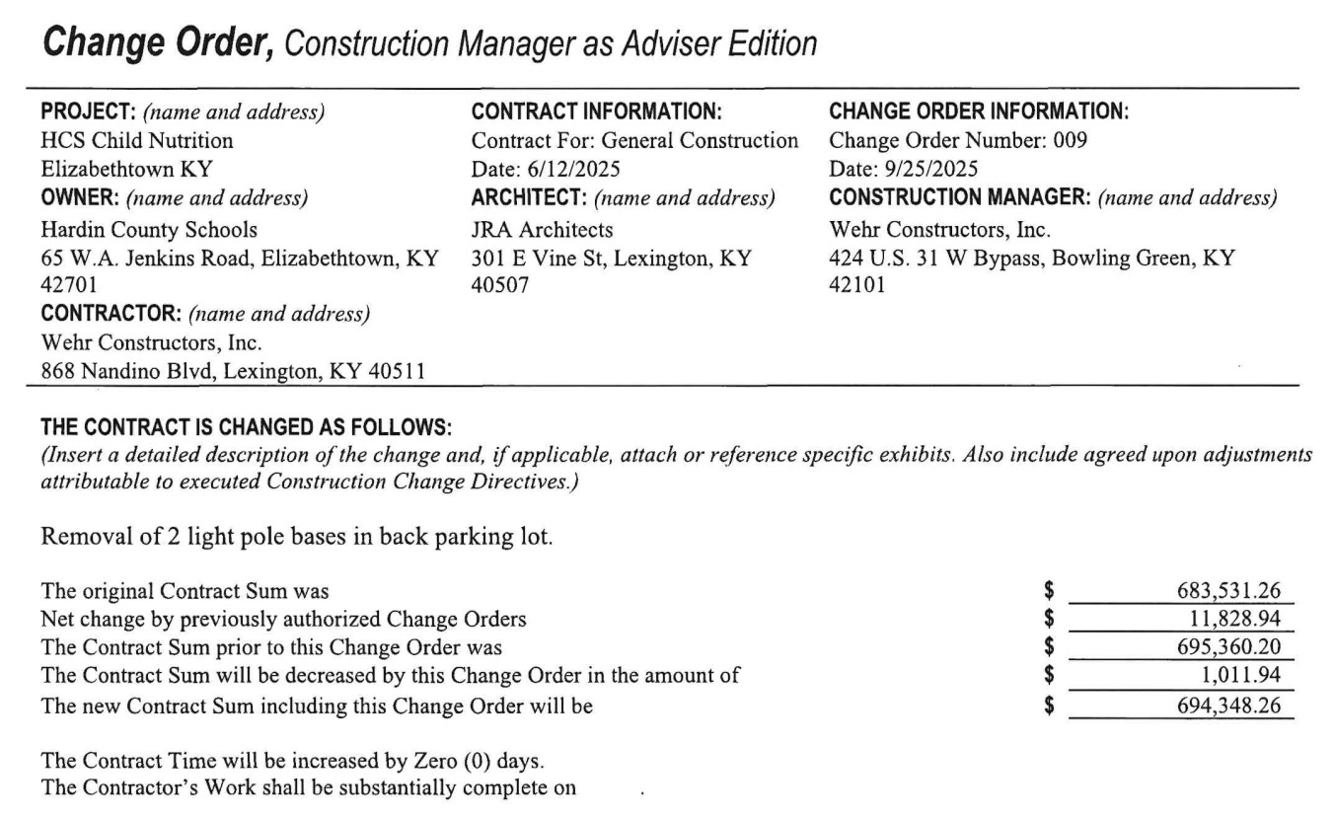

RECOMMENDATION
I RECOMMEND THE BOARD APPROVE CHANGE ORDERS 8 AND 9 FOR THE CHILD NUTRITION CONSTRUCTION PROJECT.

RECOMMENDED MOTION
I MOVE THE hardin county BOARD of education APPROVE CHANGE ORDERS 8 AND 9 FOR THE CHILD NUTRITION CONSTRUCTION PROJECT.

