Strategic Prevention Framework
I³: Inspired, Individualized, Inclusive
September 2025 - October 2025
Goal: To reduce the onset & progression of substance misuse & its related problems in Bellevue, KY, by supporting the development & delivery of community substance misuse prevention & mental health promotion services.
Objective 1: | By 9/29/2027, reduce the 30-day use of alcohol among tenth-grade students by 2% each year as measured by annual KIP survey data.
Objective 2: | By 9/29/2027, reduce regular (30-day) vaping use among tenth-grade students by 2% each year as measured by annual KIP survey data.
Objective 3: | By 9/29/2027, reduce regular (30-day) cigarette smoking among tenth-grade students by 2% each year as measured by annual KIP data.
Objective 4: | By 9/29/2027, tenth-grade students reporting serious psychological distress, according to the K6 KIP data, will decrease by 4% each year.
Objective 5: | By 9/29/2027, expand collaboration with community prevention partners, demonstrated by support from community prevention partners at least 2x each year documented by photographic evidence & meeting notes.

ASSESSMENT
Accomplishments | Description |  |  | Align
Monitoring school needs assessment activities: | Internal Referrals for mental health services.  26 internal referrals for services (12 GES/14 BMHS)  15 internal referrals accepted (1 GES/14 BMHS)  10 internal referrals in progress (10 GES/0 BMHS)  0 students fading out of services  1 internal referral for prevention services (0 GES/1 BMHS)  1 internal referral assessments completed for prevention services (0 GES/1 BMHS)  1 student fading out of services (0 GES/1 BMHS) |  |  | 1-4
Monitoring schools needs assessment activities: | External Referrals for mental health & prevention services.  1 student/family external referral  0 student/family Care Solace referrals  0 staff member's Care Solace referrals  0 external resources distributed |  |  | 1-4
Monitoring schools needs assessment activities: | As required by SAMHSA, grant staff systematically collect and monitor comprehensive data on all grant-led initiatives. This includes indirect counts of individuals reached, direct counts of participants served, outreach and engagement efforts, progress monitoring, financial reporting, data sources, demographic and enrollment information, as well as data related to mental health and prevention services and substance use referrals. SPF Grant Data Dashboard |  |  | 1-5
Specification of baseline data: | Teacher-rated SEB screeners were sent to all educators to rate student behavior for grades K-5 and 6-12. The data used within the MTSS framework to proactively detect students who need support. Enrollment data collected via Infinite Campus. BASE teams at each school review collected data to inform tiered interventions. Overall, 78% of students in the district were teacher-rated.  - *Fall 25-26 GES Universal Screener [98%]  - 200 students rated in total  - 205 students enrolled  - *Fall 25-26 BMHS Universal Screener [66%]  - 180 students rated in total (unduplicated)  - 271 students enrolled |  |  | 1-4
CAPACITY
Accomplishments | Description |  |  | Align
Professional Development: | SPF Grant Staff:  - 09/23 - Character Strong: Creating the system to implement & monitor tier 2 supports  - 9/29 - KCSS - High in Plain Sight: Current Drug Trends  - 10/03 - Empowering Professionals to Support Children and Youth Impacted by Family Substance Use  - 10/08 - Mental Health Instruction.Org: Vetted Content for K-12 Educators | - 10/09 - Using REACH Lab's Data Dashboard To Inform Your Work & Collect Clean Data  - 10/09 - Stanford's REACH Lab - Who We Are and Our Resources  - 10/09 – REACH Lab - Safety First Curriculum Training  - 10/10 - Ignoring the Warning Signs: The Cost of Neglecting Mental Health in Schools  - 10/13 - Character Strong with Tier 2 to Activate Early Intervention |  | 5
Building internal coalitions: | Grant staff participated in the following monthly coalition/committee meetings: |  |  | 5
Building internal coalitions: | - Mental Health & Prevention Staff Meeting  - MTSS Planning Meeting  - GES BASE meeting | - BMHS BASE Meeting  - BMHS Referral Meeting  - SPF/BMHS Weekly Meeting
Building external coalitions: | Grant staff participated in the following monthly coalition/committee meetings: |  |  | 5
Building external coalitions: | - NKY ASAP  - SBMH Grant Committee Meeting  - TISS Grant Committee Meeting  - Adult Allies | - SAMHSA – SPF Grant  - 2025 Coalition Academy  - Campbell County Drug-Free Alliance General Meeting  - River Cities Drug-Free Coalition Meeting
Building external partnerships: | Grant staff meet with the following community agencies: |  |  | 5
Building external partnerships: | - Character Strong  - Care Solace  - Girls on the Run  - Apple Company | - Sun Behavioral  - Ape Made It  - Perfetti Van Melle
Community Conversations: | - Sun – Mobile Assessor  - Perfetti Van Melle | - First Friday on Fairfield  - Ape Made It |  | 5
Other infrastructure development: | - Review & update the MH&Prevention Webpage with resources weekly  - BISD Resource Mapping review & update support for students, staff, & families |  |  | 5
PLANNING
Accomplishments | Description |  |  | Align
Articulation of a vision for prevention activities: | Grant staff are working toward planning the following:  OCTOBER  - 10/17 - SPF Newsletter #1  - 10/22 – Apple Day  - 10/22 - Unity Day  - 10/25 - National Take Back Day  - 10/28 – NKY Youth Summit  - 10/23-10/31 - Red Ribbon Week  NOVEMBER  - 11/11 - Dinner Table Project #1  - 11/13 - World Kindness Day  - 11/17 – SPF Advisory Meeting  - 11/21 – Holiday Newsletter Mini | DECEMBER  - TBD – Newsletter #2  - TBD – Holiday Walk (Bellevue Business)  - TBD – SMILE Club Holiday Book Reading  Ongoing Initiatives:  - TBD – First Friday: Spill the Tea  - Girls on the Run (Tuesday & Thursday)  - SMILE Club (High School Tuesday)  - SMILE Club (Middle School Thursday)  - GES – Tier 2 Groups
IMPLEMENTATION
Accomplishments | Description |  |  | Align
Specific community-level interventions being implemented: | SEPTEMBER  - 09/12 – 9/19 – Tiger Tracks (I Matter)  - 09/15 -9/19 - Hoco Posters – Refusal Skills  - 09/16 – Adult Allies  - 09/17 - 2025 Coalition Academy  - 09/17 - ERD SEB Screener Presentation  - 09/17 – Coalition Conference  - 09/18 – NKCES MTSS Conference  - 09/22 – SPF Advisory Meeting  - 09/24 – SMILE Club Positive Poster  - 09/26 – Kroger Wellness Resource Fair  - 09/30 – KPN Conference | OCTOBER  - 10/03 – First Friday: Spill the Tea  - 10/02 – NKU Wellness Resource Fair  - 10/08 – CCDFA Retreat  - 10/10 - World Mental Health Day  Ongoing Initiatives:  - Girls on the Run (Tuesday & Thursday)  - SMILE Club (High School Tuesday)  - SMILE Club (Middle School Thursday) |  | 1-4
NKCES MTSS Conference
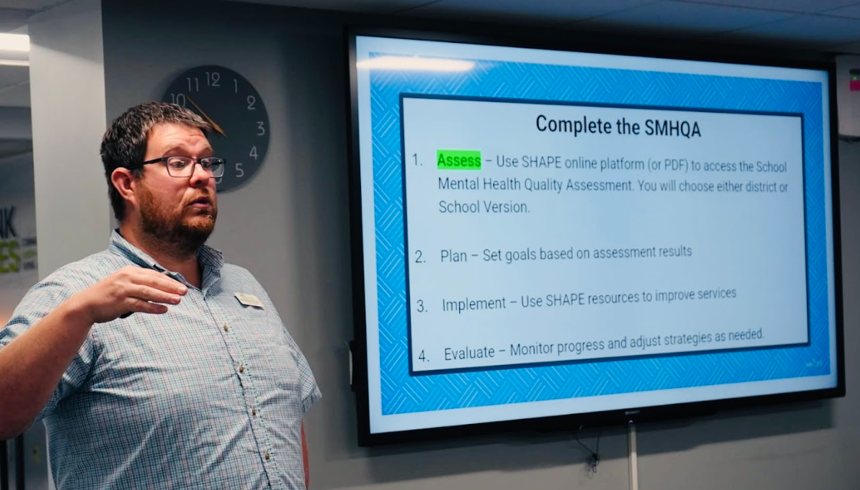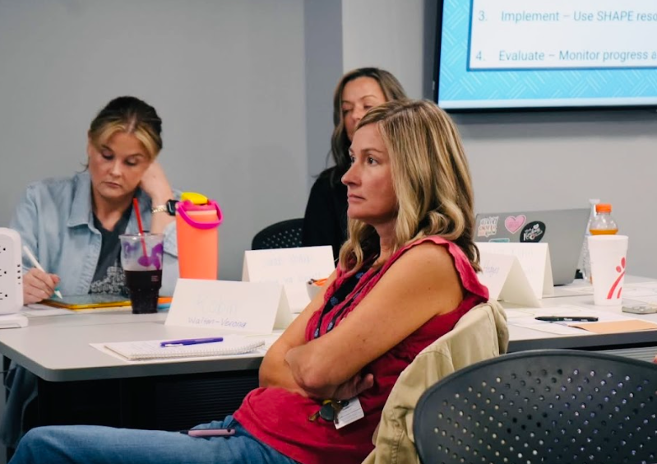

Kroger Wellness Resource Fair
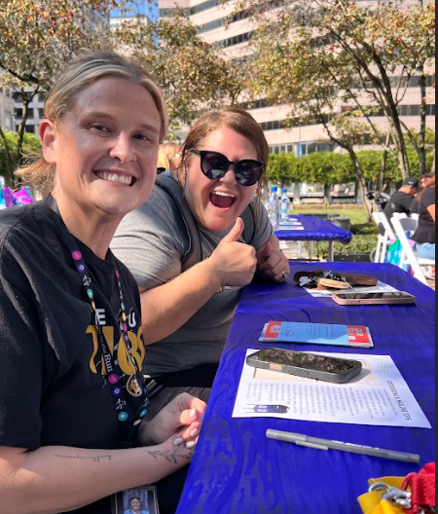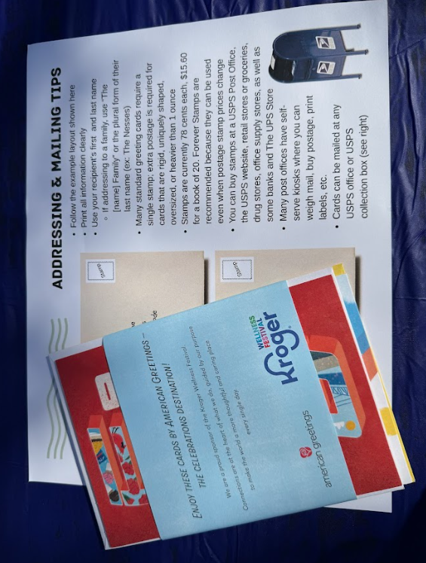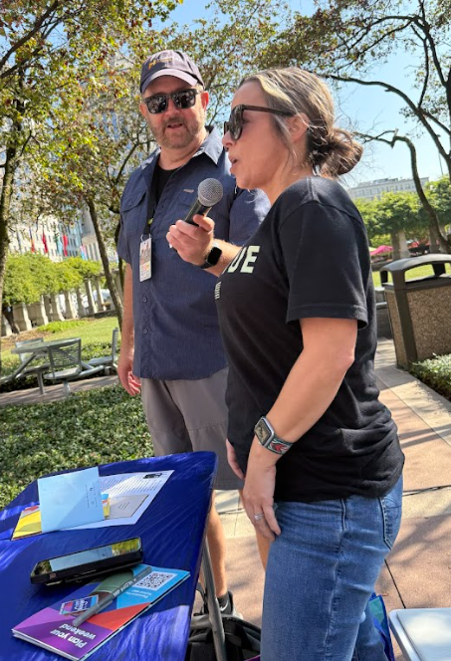

KPN Conference
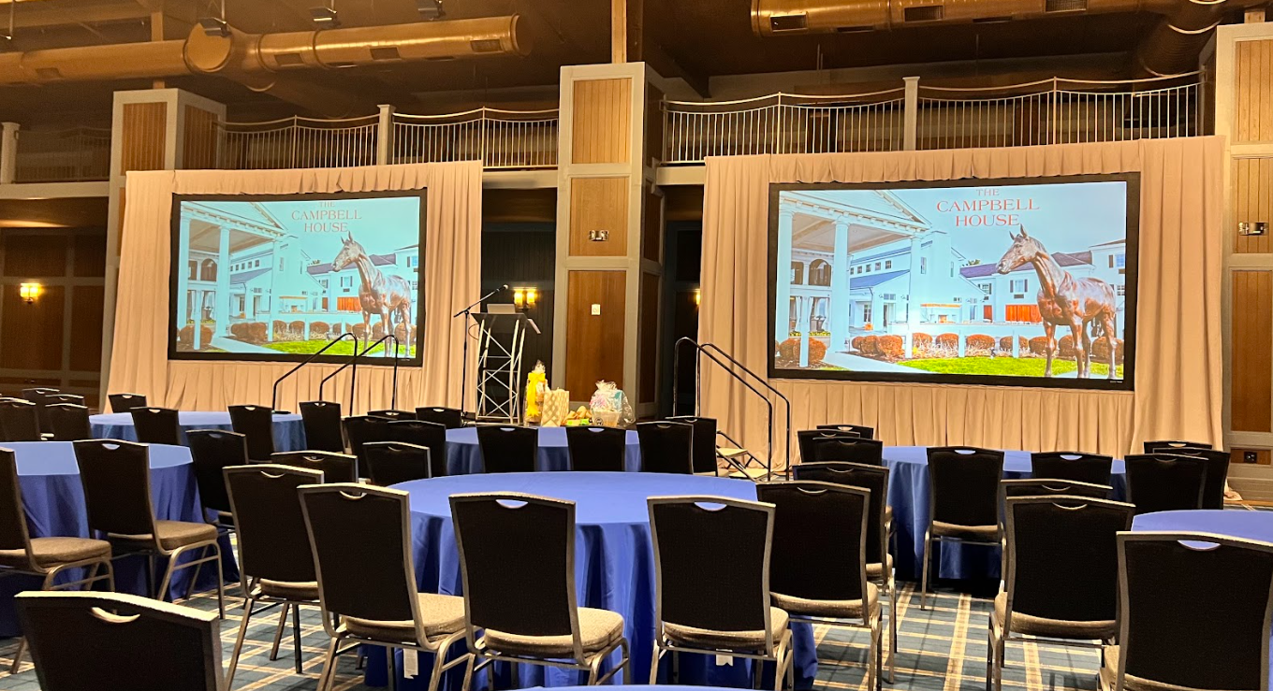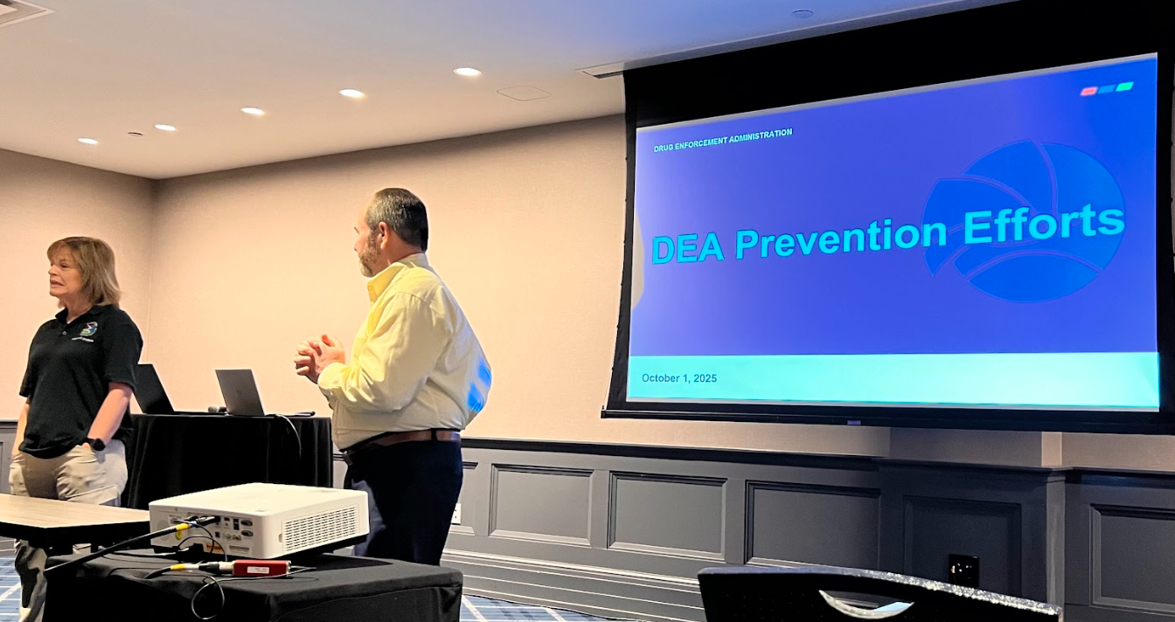

SMILE Club Positive Posters
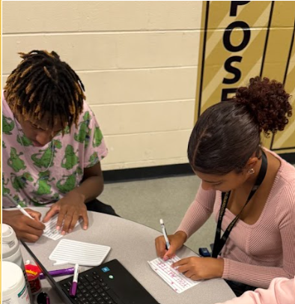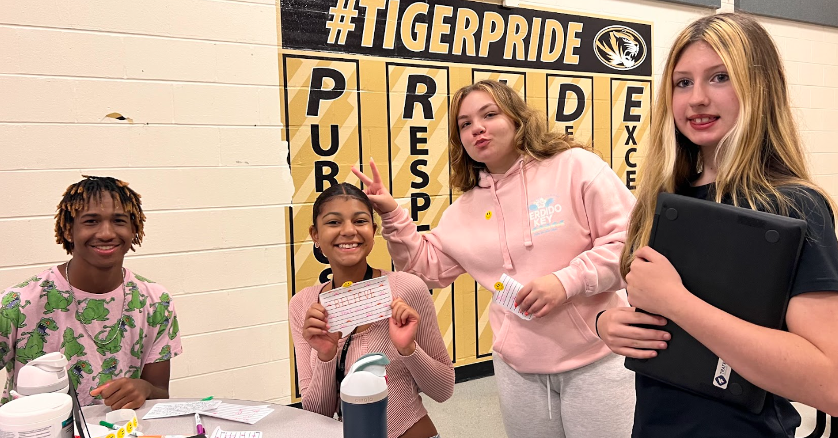
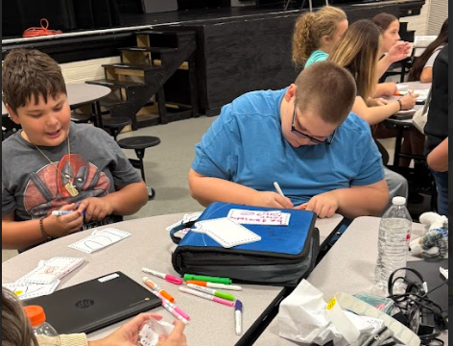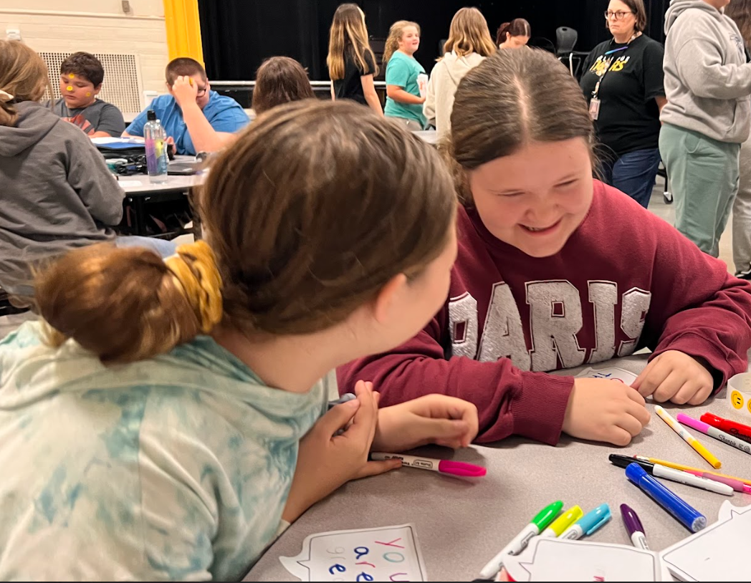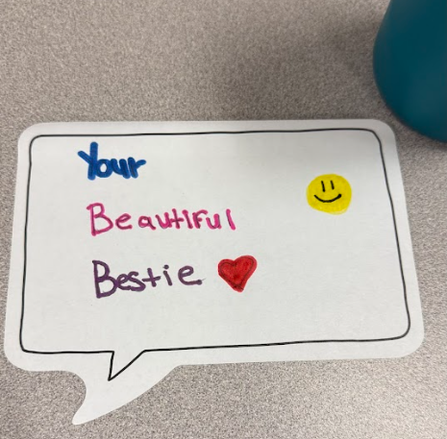

First Friday on Fairfield
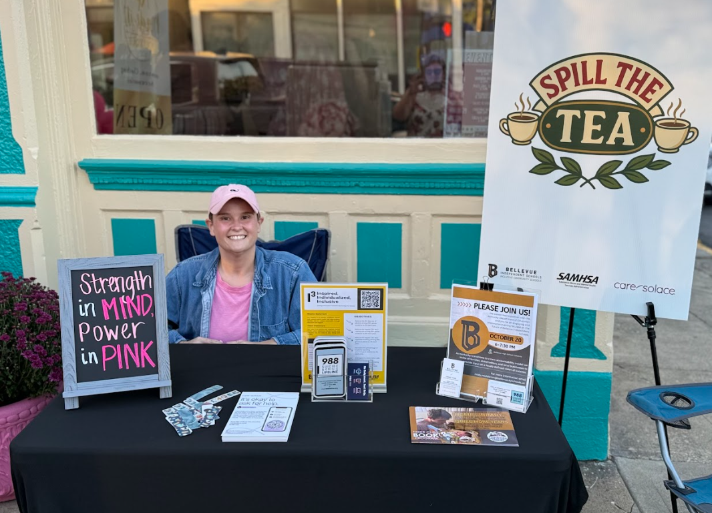

Implemented policies within organizations to facilitate interventions | Grant staff works with the following grants to create procedures for the BISD mental health & prevention team in response to students' & families' mental health & prevention needs. These align with the best practices.  - Trauma-Informed Grant  - Grant staff continues to work with TISS Grant to revise BISD’s trauma-informed plan & create action steps to ensure the implementation of best practices.  - Grant staff continues to work with SBMH Grant to review & revise BISD’s Mental Health plan & create action steps to ensure the implementation of best practices.  - School-Based Mental Health Grant  - Grant staff continues to work with SBMH Grant to review & revise BISD’s Mental Health plan & create action steps to ensure the implementation of best practices.  - Prevention  - Grant staff continues to review & revise BISD’s Prevention plan, creating action steps to ensure the implementation of best practices.  - Created district tobacco/nicotine-free procedure in response to HB-142; the procedure was added to the Code of Conduct and middle/high school behavior matrix. |  |  | 4
Specific community-level interventions being implemented: | SBMH Breakdown of time and/or student reached/seen:  - Direct: 0  - Total Sessions: 0  - Extra Sessions: 0 extra sessions 0 minutes = 0 hours  - Indirect: 0 minutes = 0 hours |  | SBMH GES Caseload Numbers:  - Active cases: 0  - Tier 2 performance: 0  - Internal Referrals: 0  - Total referred, awaiting consent in last month: 0  - Total fading out of services in last month: 0  - All students have been discharged for the summer. | 4
Specific community-level interventions being implemented: | Prevention Breakdown of time and/or student reached/seen:  - Total sessions: 0  - Total direct sessions: 0  - Total extra sessions: 0  - Groups: 0  - Tier 2 performance: 0 |  | Prevention Caseload Numbers:  - Active cases: 1  - Referrals: 1  - Pending: 0  - Tier 2 performance: 0 | 1-4
Developed systems for distributing resources: | 0 lockbox distributed to families  - 24 distributed in total |  | 0 Deterra bags distributed to families  - 0 distributed in total  - 75 available | 1-3
EVALUATION
Accomplishments | Description |  |  | Align
Monitor & evaluate all activities: | As part of our federal grant requirements, staff collect (or attempt to collect) and monitor data to ensure accountability and measure the impact of all grant-funded initiatives. This includes tracking how many students, families, and community members we reach, how many directly participate in programs, and the progress they make over time. We also review financial reports, demographic and enrollment information, and data on mental health services, prevention services and activities, and substance-use related behavior referrals or incidents. Collecting this information allows us to show how funds are used and how these efforts strengthen student well-being and community health. We continue to review and revise procedures/processes to enhance and increase data literacy and collection across the district level. In addition to SPF grant-specific data, we continue to collect and monitor data for the SBMH and TISS grants. We continue to review new system requirements for data collection and revise current data collection processes as needed. |  |  | 1-4
Monitor & evaluate all activities: | SPF Grant Data Dashboard  - Data collected through data sources including demographic information, enrollment data, mental health and prevention service lines data, substance-use related behavior referrals, count of directly served, count of directly reached  - Data recorded on SPF Grant Data Dashboard  - Data submitted to SPARS each quarter, then annually  - Data included in BOE reports monthly  - Reviewing new system requirements for data collection and revising current data collection processes |  |  | 1-5
Monitor & evaluate all activities: | KEY METRICS (SPF Grant Data Dashboard)  Indirect  - Total Individuals Reached (Actual), 1570  - Total Individuals Reached (Estimated), 884  - Total New Individuals Reached (Unduplicated), 860  - Total Individuals Reached, 2454  Direct  Total Individuals Served (Actual), 476  Total Individuals Served (Estimated), 0  Total New Individuals Served This FY, 2 |  |  | 1-5
Monitor & evaluate all activities: | Creating process to evaluate outreach data and increased prevention messaging data for this academic year to inform decisions and initiatives for the next academic year. |  |  | 1-5
Grant Reporting: | - 12/31 – SPF eRa Commons Annual Performance Report – Under Review  - 01/31 – SPF Continuation Report – Under Review  - 04/15 – SPF eRa Commons Carryover – Approved  - 05/05 – Annual Target Report – Approved  - 05/26 – SPF SPARS Quarter 1 Report – Approved  - 06/23 – SPF SPARS Quarter 2 Report – Submitted  - 07/23 – SPF SPARS Quarter 3 Report – Due (unable to complete until Q2 is approved)  - 10/31 – SPF SPARS Quarter 4 Report – Due (unable to complete until Q2 is approved) |  |  | 1-5

SUSTAINABILITY
Sustaining infrastructure: | Continue developing & improving the district's MTSS system & mental health support.

