CONSENT ITEM
October 15, 2025
OLDHAM COUNTY BOARD OF EDUCATION
CONCERN
Consider Approval of School Fundraising Requests
DISCUSSION
Additional Fundraisers for FY26
School/Dept | Group | Event
Goshen | Goshen PTO | Personalized Bricks
Goshen | Goshen PTO | $1 days for 5th Grade Legacy Gift
Harmony | Harmony PTA | Pasta Sale
*Post approval
RECOMMENDATION
Approve fundraising requests as submitted and authorize the Superintendent to approve on a case-by-case basis, in accordance with appropriate policies and regulations, any additional fundraisers.

Motion Passed: Motion by _______________, seconded by _______________, the Board approved the attached contracts and authorized the Superintendent and Secretary of the Board, or his designee, to execute all of the above contracts for formal approval. ( , )

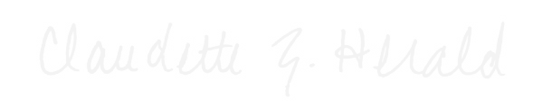

Carly Clem, Board Chair Claudette Herald, Superintendent

