CONSENT ITEM A
July 28, 2025
OLDHAM COUNTY BOARD OF EDUCATION
CONCERN
Consider post approval of overnight field trips.
DISCUSSION
Due to changes in the board meeting dates in June, a few overnight field trips were not approved prior to the travel dates.
SCHOOL | GROUP | LOCATION/DATE | JUSTIFICATION | INSTR. DAYS LOST
SOHS | Dance Team | UofL  July 10-13, 2025 | Overnight: Training Camp  Parents | 0
SOHS | Boys Basketball | Lexington, KY  June 23, 2025 | Overnight: Basketball Camp  Bus or Parents Transport | 0
Approve the field trips as attached and described above, pursuant to the condition that students not traveling on school buses, with their parents, or with a Board employee whose insurance carrier has named OCBE as an additional named insured, will be transported to and from their destination on an approved charter bus(es) and school(s) shall obtain written evidence of liability.

Motion Passed: Motion by _______________, seconded by _______________, the Board gave approval of the field trips as attached and described above, pursuant to the condition that students not traveling on school buses, with their parents, or with a Board employee whose insurance carrier has named OCBE as an additional named insured, will be transported to and from their destination on an approved charter bus(es) and school(s) shall obtain written evidence of liability. ( , )

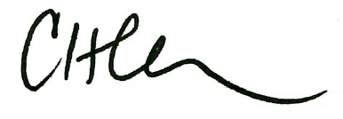
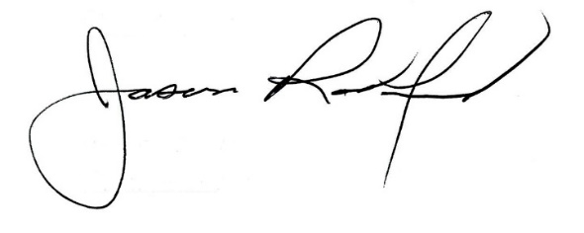

Carly Clem, Board Chair Claudette Herald, Superintendent/Secretary

