CONSENT ITEM A
July 28, 2025
OLDHAM COUNTY BOARD OF EDUCATION
CONCERN
Consider Approval of Field Trips Requesting Overnight Stay & Field Trips Requesting Use of Common Carrier.
DISCUSSION
The following are field trips requesting overnight stay and trips requesting use of a common carrier:
SCHOOL | GROUP | LOCATION/DATE | JUSTIFICATION | INSTR. DAYS LOST
SOHS | Dance Team | UofL  July 10-13, 2025 | Overnight: Training Camp  Parents | 0
SOHS | Girls Soccer | Notre Dame Academy  August 16, 2025 | Overnight: Soccer Game  Bus or Parent Transport | 0
SOHS | Cross Country | Richmond HS (IN)  August 22-24, 2025 | Overnight: Game  Bus or Parent Transport | 0
SOHS | Field Hockey | St. Louis  August 29-31, 2025 | Overnight: Tournament  Parents | 0
SOHS | Boys Golf | UK club  September 13-14, 2025 | Overnight: Golf Match  Parents | 0
SOHS | Girls Golf | Lexington, KY  September 13-14, 2025 | Overnight: Golf Match  Parents | 0
SOHS | Boys Golf | Pendleton Hills CC  September 29, 2025 | Overnight: Golf Match  Parents | 0
SOHS | Girls Golf | Butler, KY  September 29, 2025 | Overnight: Semi State Tournament  Parents | 0
SOHS | Girls Golf | Lexington, KY  October 7-8, 2025 | Overnight: State Tournament  Parents | 2
SOHS | Boys Golf | Bowling Green CC  October 9-11, 2025 | Overnight: Golf Match  Parents | 0
SOHS | Volleyball | TBD  TBD | Overnight: Tournament  Bus or Parents Transport | 0
OCHS | Band | Chicago, IL  April 17-21,2026 | Overnight: Instructional Field Trip  Charter Bus | 2
SOHS | Boys Basketball | Lexington, KY  June 23, 2025 | Overnight: Basketball Camp  Bus or Parents Transport | 0
OCMS | Nature Club | Great Smoky Mountains Institute at Tremont  April 20-22, 2026 | Overnight: Instructional Field Trip  Common Carrier | 3
OCHS/SOHS | Choir | Orlando, Fl  March 25-30, 2026 | Overnight: Instructional Field Trip  Common Carrier | 4
Approve the field trips as attached and described above, pursuant to the condition that students not traveling on school buses, with their parents, or with a Board employee whose insurance carrier has named OCBE as an additional named insured, will be transported to and from their destination on an approved charter bus(es) and school(s) shall obtain written evidence of liability.

Motion Passed: Motion by _______________, seconded by _______________, the Board gave approval of the field trips as attached and described above, pursuant to the condition that students not traveling on school buses, with their parents, or with a Board employee whose insurance carrier has named OCBE as an additional named insured, will be transported to and from their destination on an approved charter bus(es) and school(s) shall obtain written evidence of liability. ( , )


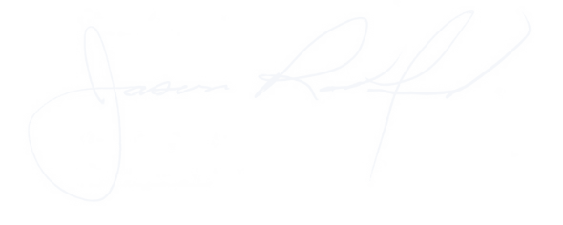

Carly Clem, Board Chair Claudette Herald, Superintendent/Secretary

