ACTION ITEM A
July 28, 2025
OLDHAM COUNTY BOARD OF EDUCATION
CONCERN
Consider Approval of requested Policy Revisions.
DISCUSSION
Consider Approval of policy revisions listed below.
NUMBER | NAME OF POLICY | REASON FOR AMENDMENT/ADDITION
Policy – 1st read
002_Pol | Numerous updates | Please read the document from KSBA for legal updates
002_AP | Numerous updates | Please read the document from KSBA for legal updates
03.221 | Salaries | Waiver on how experience is granted for Military Service
03.273 | Retirement | Please read the document from KSBA for legal updates
03.122 | Holidays and Annual Leave | Corrections on Non Contract Days

RECOMMENDATION
Approve requested policy revisions.

Motion Passed: On a motion by _______________, seconded by _______________, the Board approved the requested policy revisions. ( , )

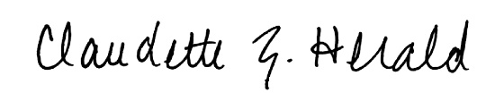
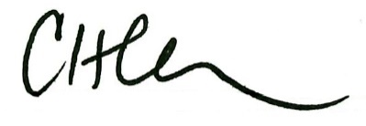

Carly Clem, Board Chair Claudette Herald, Superintendent/Secretary

