CONSENT ITEM H
July 28, 2025
OLDHAM COUNTY BOARD OF EDUCATION
CONCERN
Consider Approval of Additional 2025 Oldham County High School and Buckner Alternative High School Graduates.
DISCUSSION
The following students have completed graduation requirements for 2025.
- Zachary Johnson
- Jay Smith
- Aiden Katsoulis
- Wyatt Shelden
- Joseph Nalley
RECOMMENDATION
Approve the graduating seniors for the Class of 2025.

On a motion by _______________, seconded by _______________, the Board approved the graduating seniors for the Class of 2025. ( , )

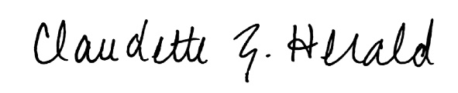


Carly Clem, Board Chair Claudette Herald, Superintendent/Secretary

