I. CALL TO ORDER, INVOCATION, PLEDGE OF ALLEGIANCE TO FLAG
Mr. James Milam, Board Chair, called the meeting to order at 6:02 PM, offered the invocation and led the audience in the pledge of allegiance to the flag.

a. Review of District Mission Statement
Mr. Milam reviewed the district mission and vision statements: “At Russellville Independent Schools, we are committed to ensuring that every Panther is equipped socially, emotionally, and academically on their journey to becoming an effective communicator, productive collaborator, innovative problem solver, and compassionate citizen – wherever life takes them!”
We R Equipping Panthers….For Life!

III. AGENDA APPROVED
Order #159 – Motion Passed: Approval of board agenda passed with a motion by Mrs. April Triplett, second by Mrs. Lovis Patterson.

Mr. James Milam Yes
Mr. Phillip West Yes
Mrs. Lovis Patterson Yes
Mrs. April Triplett Yes
Ms. Shawnri Gamble Absent

IV. PUBLIC COMMENT

V. PRESENTATIONS
a. Proposed District Vision/Mission Statement
Dr. Kelly Jones presented the board with a proposed updated vision and mission statement that relates back to our strategic plan.

VI. CONSENT AGENDA ITEMS APPROVED
Order #160 – Motion Passed: Approval of the Consent Agenda Items passed with a motion by Mrs. Lovis Patterson and a second by Mr. Phillip West.

Mr. James Milam Yes
Mr. Phillip West Yes
Mrs. Lovis Patterson Yes
Mrs. April Triplett Yes
Ms. Shawnri Gamble Absent

- Minutes: May 22, 2025, Special Called Meeting & May 22, 2025, Second Special Called Meeting
- Payment of Claims & Contract Salaries and Financial Reports
- Report of Personnel Actions Taken by the Superintendent
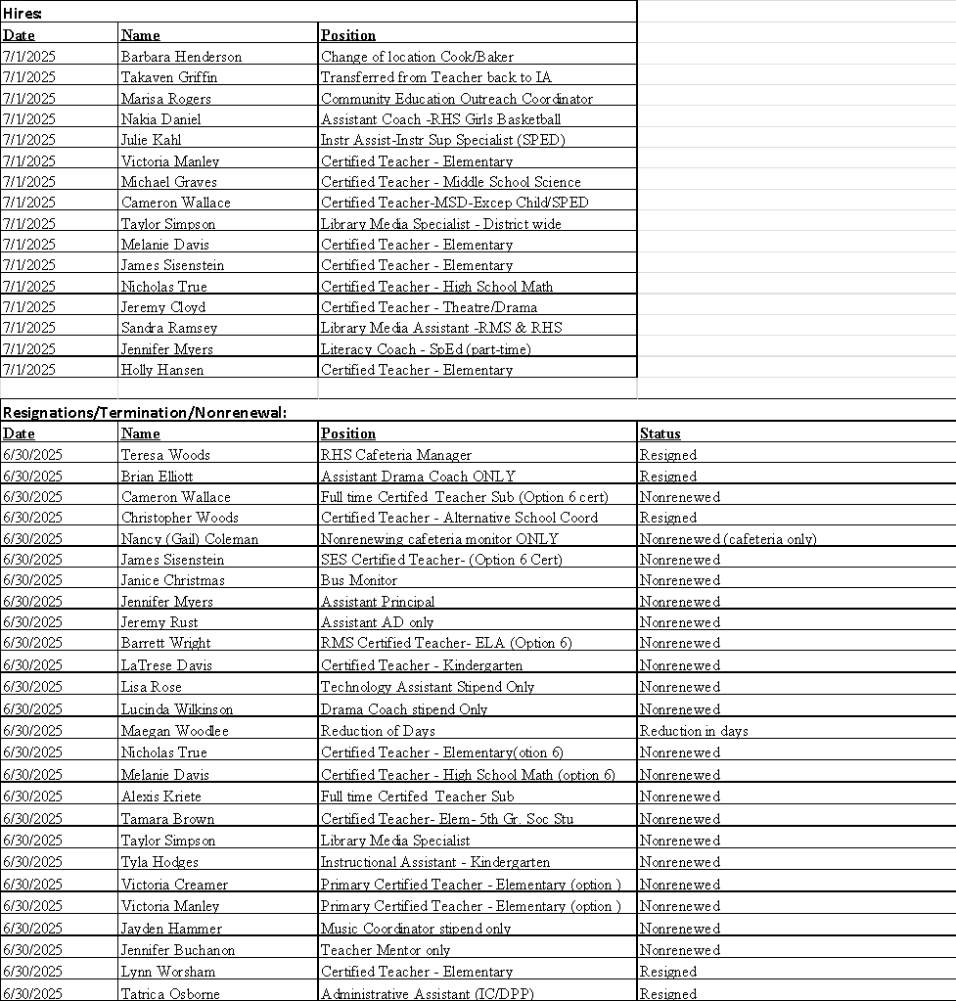

- Fundraiser/Overnight Travel
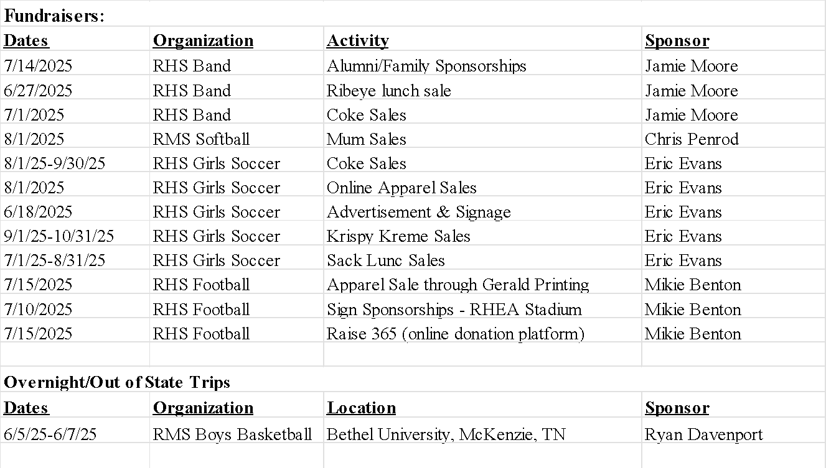
- Shortened School Day for Student 002
- GASB-54 Fund Balance Reserves
- District Funding Assurance Statement

VI. UPDATE/INFORMATION ON DISTRICT PROGRAMS/ACTIVITIES
- Pay Application #3 for Russellville High School HVAC Renovation Project (BG25-108)
Order #161 - Motion Passed: Approval of pay application #3 for RHS HVAC project (BG25-108) passed with a motion by Mrs. April Triplett and a second by Mrs. Lovis Patterson.

Mr. James Milam Yes
Mr. Phillip West Yes
Mrs. Lovis Patterson Yes
Mrs. April Triplett Yes
Ms. Shawnri Gamble Absent

- Approve Change Order #1 for Russellville High School Culinary Project (BG25-203)
Order #162 - Motion Passed: Approval of change order #1 for RHS culinary project (BG25-203) passed with a motion by Mr. Phillip West and a second by Mrs. April Triplett.

Mr. James Milam Yes
Mr. Phillip West Yes
Mrs. Lovis Patterson Yes
Mrs. April Triplett Yes
Ms. Shawnri Gamble Absent

- First Reading of the 2025-2026 Policy and Procedure Updates
Order #163 – Motion Passed: Approval of the 2025-26 policy and procedure first reading passed with a motion by Mr. Phillip West and a second by Mrs. April Triplett.

Mr. James Milam Yes
Mr. Phillip West Yes
Mrs. Lovis Patterson Yes
Mrs. April Triplett Yes
Ms. Shawnri Gamble Absent

- Approve Local Planning Committee for District Facility Plan
Order #164 – Motion Passed: Approval of local planning committee for district facility plan passed with a motion by Mr. Phillip West and a second by Mrs. Lovis Patterson.

Mr. James Milam Yes
Mr. Phillip West Yes
Mrs. Lovis Patterson Yes
Mrs. April Triplett Yes
Ms. Shawnri Gamble Absent

- Pay Application #1 for Russellville High School Culinary Project (BG25-203)
Order # 165 – Motion Passed: Approval of pay application #1 for RHS culinary project (BG25-203) passed with a motion by Mrs. April Triplett and a second by Mr. Phillip West.

Mr. James Milam Yes
Mr. Phillip West Yes
Mrs. Lovis Patterson Yes
Mrs. April Triplett Yes
Ms. Shawnri Gamble Absent

- Pay Application #2 for Russellville High School Culinary Project (BG25-203)
Order #166 - Motion Passed: Approval of pay application #2 for RHS culinary project (BG25-203) passed with a motion by Mrs. Lovis Patterson and a second by Mr. Phillip West.

Mr. James Milam Yes
Mr. Phillip West Yes
Mrs. Lovis Patterson Yes
Mrs. April Triplett Yes
Ms. Shawnri Gamble Absent

- General Property & Liability Insurance Renewal
Order #167 - Motion Passed: A motion was made by Mrs. Lovis Patterson to approve the general property and liability insurance renewal with no additional optional coverages and no additional option for buy down coverages. The motion was seconded by Mr. Phillip West.

Mr. James Milam Yes
Mr. Phillip West Yes
Mrs. Lovis Patterson Yes
Mrs. April Triplett Yes
Ms. Shawnri Gamble Absent

VII. NEW BUSINESS

- 2025-2026 Bus Maintenance Contract with Logan County School District
Order #168 - Motion Passed: Approval of the 2025-26 bus maintenance contract with Logan County School District passed with a motion by Mr. Phillip West and a second by Mrs. April Triplett.

Mr. James Milam Yes
Mr. Phillip West Yes
Mrs. Lovis Patterson Yes
Mrs. April Triplett Yes
Ms. Shawnri Gamble Absent

- 2025-2026 GRREC Membership Renewal
Order #169 - Motion Passed: Approval of the 2025-26 GRREC membership passed with a motion by Mrs. Lovis Patterson and a second by Mrs. April Triplett.

Mr. James Milam Yes
Mr. Phillip West Yes
Mrs. Lovis Patterson Yes
Mrs. April Triplett Yes
Ms. Shawnri Gamble Absent

- Certified and Classified Evaluation Plan (CEP) Annual Review
Order #170 - Motion Passed: Approval of submitted RISD 2025-26 CEP Plan passed with a motion by Mr. Phillip West and a second by Mrs. Lovis Patterson.

Mr. James Milam Yes
Mr. Phillip West Yes
Mrs. Lovis Patterson Yes
Mrs. April Triplett Yes
Ms. Shawnri Gamble Absent

- 2025-2026 Occupational Therapy Services Contract
Order #176 - Motion Passed: Approval of agreement with United Way passed with a motion by Mrs. April Triplett and a second by Mrs. Lovis Patterson.

Mr. James Milam Yes
Mr. Phillip West Yes
Mrs. Lovis Patterson Yes
Mrs. April Triplett Yes
Ms. Shawnri Gamble Absent

- 2025-2026 Contract with LifeSkills
Order #172 - Motion Passed: Approval of 2025-26 contract with LifeSkills passed with a motion by Mr. Phillip West and a second by Mrs. April Triplett.

Mr. James Milam Yes
Mr. Phillip West Yes
Mrs. Lovis Patterson Yes
Mrs. April Triplett Yes
Ms. Shawnri Gamble Absent

- Contract for Orientation and Mobility Services
Order #173 - Motion Passed: Approval of the orientation and mobility contract passed with a motion by Mrs. Lovis Patterson and a second by Mrs. April Triplett.

Mr. James Milam Yes
Mr. Phillip West Yes
Mrs. Lovis Patterson Yes
Mrs. April Triplett Yes
Ms. Shawnri Gamble Absent

- 2025-2026 Workers Compensation Renewal
Order #174 - Motion Passed: Approval of the 2025-26 workers compensation renewal passed with a motion by Mr. Phillip West and a second by Mrs. Lovis Patterson.

Mr. James Milam Yes
Mr. Phillip West Yes
Mrs. Lovis Patterson Yes
Mrs. April Triplett Yes
Ms. Shawnri Gamble Absent

- 2025-2026 District Assurances
Order #175 - Motion Passed: Approval of the FY26 District Assurances passed with a motion by Mr. Phillip West and a second by Mrs. April Triplett.

Mr. James Milam Yes
Mr. Phillip West Yes
Mrs. Lovis Patterson Yes
Mrs. April Triplett Yes
Ms. Shawnri Gamble Absent

- Agreement with United Way
Order #176 - Motion Passed: Approval of agreement with United Way passed with a motion by Mrs. April Triplett and a second by Mrs. Lovis Patterson.

Mr. James Milam Yes
Mr. Phillip West Yes
Mrs. Lovis Patterson Yes
Mrs. April Triplett Yes
Ms. Shawnri Gamble Absent

- Approve Capital Funds Request (CFR)
Order #177 - Motion Passed: Approval of CFR passed with a motion by Mr. Phillip West and a second by Mrs. April Triplett.

Mr. James Milam Yes
Mr. Phillip West Yes
Mrs. Lovis Patterson Yes
Mrs. April Triplett Yes
Ms. Shawnri Gamble Absent

- Pledge of Collateral
Order #178 - Motion Passed: Approval of pledge of collateral passed with a motion by Mrs. Lovis Patterson and a second by Mrs. April Triplett.

Mr. James Milam Yes
Mr. Phillip West Yes
Mrs. Lovis Patterson Yes
Mrs. April Triplett Yes
Ms. Shawnri Gamble Absent

- 2025-2026 Technology Plan
Order #179 - Motion Passed: Approval of 2025-26 technology plan passed with a motion by Mr. Phillip West and a second by Mrs. Lovis Patterson.

Mr. James Milam Yes
Mr. Phillip West Yes
Mrs. Lovis Patterson Yes
Mrs. April Triplett Yes
Ms. Shawnri Gamble Absent

VIII. ADMINISTRATIVE REPORTS

IX. SUPERINTENDENT’S REPORT

X. AUTHORIZATION FOR CLOSED SESSION TO CONDUCT PRELIMINARY DISCUSSIONS RELATING TO THE EVALUATION OF SUPERINTENDENT PURSUANT TO KRS 61.810(1)(f) and KRS 156.557()
Order #180 - Motion Passed: A motion was made by Mr. Phillip West and a second by Mrs. April Triplett to enter into closed session for preliminary discussions relating to the evaluation of the Superintendent by the Board or between the Board and the Superintendent prior to the Superintendent’s summative evaluation pursuant to KRS 61.810(1)(k) and KRS 156.557(6)(c).

Mr. James Milam Yes
Mr. Phillip West Yes
Mrs. Lovis Patterson Yes
Mrs. April Triplett Yes
Ms. Shawnri Gamble Absent

  - Return to Open Session
Order #181 - Motion Passed: Approval to return to open session passed with a motion by Mrs. April Triplett and a second by Mr. Phillip West.

Mr. James Milam Yes
Mr. Phillip West Yes
Mrs. Lovis Patterson Yes
Mrs. April Triplett Yes
Ms. Shawnri Gamble Absent

  - Adoption of Summative Evaluation of the Superintendent Pursuant to KRS 156.557(4)
Order #182 - Motion to Table: A motion to table the confirmation of the superintendent’s evaluation until Mrs. Gamble can provide input passed with a motion by Mrs. April Triplett and a second by Mr. Phillip West.

Mr. James Milam Yes
Mr. Phillip West Yes
Mrs. Lovis Patterson Yes
Mrs. April Triplett Yes
Ms. Shawnri Gamble Absent

XI. WORKING SESSION

XII. ADJOURNMENT
Order #183 - Motion Passed: passed with a motion by Mr. Phillip West and a second by Mrs. April Triplett.

Mr. James Milam Yes
Mr. Phillip West Yes
Mrs. Lovis Patterson Yes
Mrs. April Triplett Yes
Ms. Shawnri Gamble Absent

Chairman __________________________ Secretary_____________________

