THIS IS A DECISION PAPER

TO: HARDIN COUNTY BOARD OF EDUCATION

FROM: TERESA MORGAN, SUPERINTENDENT

DATE: July 17th, 2025

SUBJECT: APPROVAL OF ONE CHANGE ORDER 7 FOR THE CHILD NUTRITION CONSTRUCTION PROJECT

ISSUE:
Change Order 7 is a debit of $ 27,594.60 and is for unsuitable soil.

FACTS:

CO 7

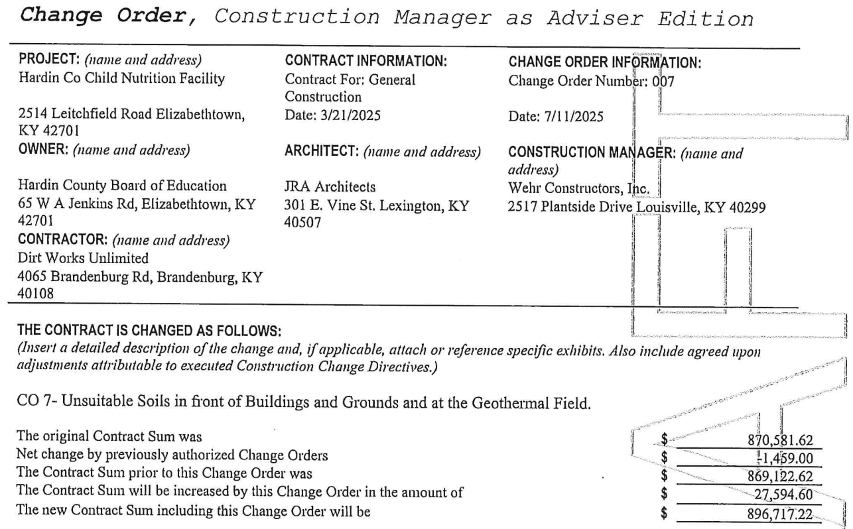

RECOMMENDATION
I RECOMMEND THE BOARD APPROVE CHANGE ORDER 7 FOR THE CHILD NUTRITION CONSTRUCTION PROJECT.

RECOMMENDED MOTION
I MOVE THE HARDIN COUNTY BOARD OF EDUCATION APPROVE CHANGE ORDER 7 FOR THE CHILD NUTRITION CONSTRUCTION PROJECT.

