MINUTES
July28, 2025
OLDHAM COUNTY BOARD OF EDUCATION

CONCERN
Consider Approval of Meeting Minutes.

DISCUSSION
The draft minutes of the June 9, 2025 – Special Called Regular and June 25, 2025, Special Called Meeting are available for review and approval.

RECOMMENDATION
Approve the minutes of the following meetings as presented.

June 9, 2025 – Special Called Regular Meeting
(1) Carly Clem, Chairperson, (2) Allison Sheffer, Board Vice Chairman; (3) Adam Springer, Board Member, and Dr. Jason Radford, Superintendent and Secretary to the Board were present.

June 25, 2025 –Special Called Meeting
(1) Carly Clem, Chairperson, (2) Allison Sheffer, Board Vice Chairman; (3) Suzanne Hundley, Board Member (4) Adam Springer, Board Member were present.

On a motion by _______________, seconded by _______________, the Board approved the minutes of the June 9, 2025 – Special Called Regular Meeting. ( , )
On a motion by _______________, seconded by _______________, the Board approved the minutes of the June 25, 2025 – Special Called Meeting. ( , )

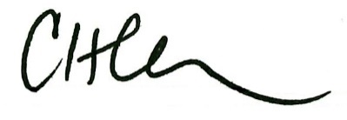
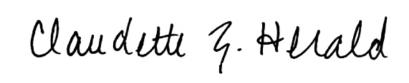

Carly Clem, Board Chair Claudette Herald, Superintendent/Secretary

