CONSENT ITEM F
July 28, 2025
OLDHAM COUNTY BOARD OF EDUCATION
CONCERN
Consider renewal of fleet, property, general liability, and workers’ compensation insurance contracts.
DISCUSSION
Jay Hall/Public Risk Placement has submitted a renewal quote from Liberty Mutual Insurance for fleet, property, general liability, and umbrella coverage, and a quote from KEMI for workers compensation insurance. Liberty Mutual has been the district’s insurer since 1995, and KEMI has provided workers’ compensation coverage for the past 10 years. The market for school district insurance coverage in Kentucky is fairly small, with only 2 companies willing to write the comprehensive school policies.
This year we are able to renew our insurance coverage through Liberty with a slight rate increase in our property, fleet, GL and umbrella premiums, and workers’ compensation premium. Our renewal premiums are as follows:
 | 2022-2023 | 2023-2024 | 2024-2025 | 2025-2026
Workers Compensation Insurance | $275,756.55 | $297,534.88 | $274,198.63 | $328,149.76
Fleet, general liability, property and  umbrella insurance | $861,910.00 | $1,014,454.00 | $1,287,737.00 | $1,490,331.00
Total | $1,137,666.55 | $1,137,666.55 | $1,311,988.88 | $1,818,480.76

RECOMMENDATION
Renew our insurance policies through Insurance Associates for property, general liability, fleet, umbrella and workers’ compensation coverage.

On a motion by __________, seconded by __________, the Board approved the Renewal of our insurance policies through Insurance Associates for property, general liability, fleet, umbrella and workers’ compensation coverage as presented. ( , )

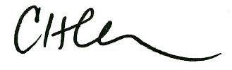
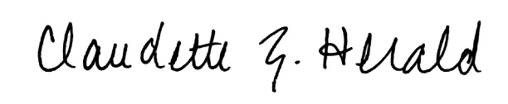

Carly Clem, Board Chair Claudette Herald, Superintendent/Secretary

