CONSENT ITEM M
June 9, 2025
OLDHAM COUNTY BOARD OF EDUCATION
CONCERN
Consider Renewal of Contract of Occupational Health Services for Staff & Students Drug Testing
DISCUSSION
A Request for Proposal (RFP) was created for Occupational Health Services, and a selection committee reviewed submissions from Baptist Health Occupational Medicine and NAO Medical. Enclosed are the proposed contracts, including detailed pricing for individual services offered by each provider.
After thorough evaluation, the committee recommends renewing the contract with Baptist Health Occupational Medicine. This recommendation is based on their competitive pricing, convenient location, comprehensive services offered, and positive prior experience with the district. Baptist Health’s staff continues to be responsive to the district’s needs and voluntarily recommends changes in procedures and services that align with the best interests of the Board.
RECOMMENDATION
Renew the contract for Occupational Health Services that includes staff and student drug testing, with Baptist Health Occupational Medicine for the 2025–2026 and 2026–2027 school years. The agreement includes the option to extend for two additional years.

Motion Passed: Motion by _______________, seconded by _______________, the Board approved the renewal of the contract for Occupational Health Services that includes staff and student drug testing, with Baptist Health Occupational Medicine for the 2025–2026 and 2026–2027 school years. The agreement includes the option to extend for two additional years. ( , )


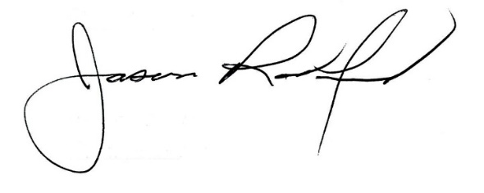

Carly Clem, Board Chair Jason Radford, Superintendent/Secretary

