CONSENT ITEM L
June 9, 2025
OLDHAM COUNTY BOARD OF EDUCATION
CONCERN
Consider Shortened School Day request for Kenwood student
DISCUSSION
Student LW, 2nd grader, at Kenwood Station. Leg surgery and has been cleared to return to school half days until April 22, 2025. He is transitioning from Homebound instruction to being able to attend in person. Cincinnati Children’s Hospital is requesting that the student attend school on a shortened school day. His time of attendance would begin at 7:40 am and end at 11:00 am.
RECOMMENDATION
Approve the Shortened School Day request for Kenwood Station student until April 22, 2025. This is a post approval.

Motion Passed: Motion by _______________, seconded by _______________, the Board approved the Shortened School Day request for Kenwood Station student until April 22, 2025. ( , )


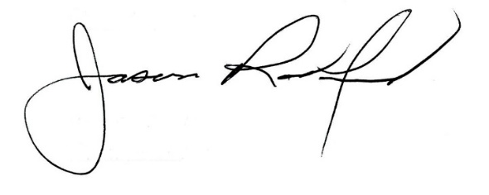

Carly Clem, Board Chair Jason Radford, Superintendent/Secretary

