CONSENT ITEM K
June 9, 2025
OLDHAM COUNTY BOARD OF EDUCATION
CONCERN
Consider approval of Bond of Depository and pledge of collateral from Stockyards Bank for fiscal year 2025-26.
DISCUSSION
In accordance with KRS 41.240, the depository institution should pledge or provide enough collateral which, together with FDIC insurance, equals or always exceeds the amount of public funds on deposit.
The Pledge of Collateral demonstrates collateral in an amount at least equal to deposits in the form of secured funds or a surety bond. KDE requires districts to update the Pledge of Collateral information annually.
RECOMMENDATION
Approve the Bond of Depository and pledge of collateral from Stockyards Bank for fiscal year 2025-26.

On a motion by _______________, seconded by _______________, the Board approved the Bond of Depository and pledge of collateral from Stockyards Bank for fiscal year 2025-26. (_,_)

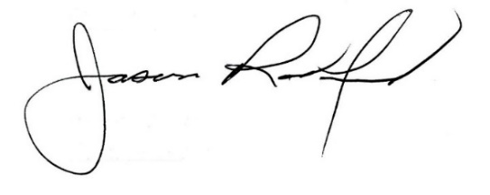


Carley Clem, Board Chair Jason Radford, Superintendent/Secretary

