CONSENT ITEM J
June 9, 2025
OLDHAM COUNTY BOARD OF EDUCATION
CONCERN
Consider approval of fidelity (surety) bonds for Chief Financial Officer/ Treasurer, Kerri Alexander as sized and required by the Kentucky Department of Education (KDE).
DISCUSSION
KRS 160.560 requires each board of education to elect a treasurer. The statute also requires the treasurer to execute an official bond for the faithful performance of the duties of their office. Further, 702 KAR 3:080, requires the bond to be submitted to KDE at the established minimum bond amount or more based upon an exposure factor provided by KDE. The required minimum bond for Oldham County based on the district annual budget is $1,000,000. Please see attached documentation.
RECOMMENDATION
Approve the fidelity bond for Chief Financial Officer/Treasurer, Kerri Alexander for submission to KDE.

On a motion by _____________, seconded by ____________, the Board approved the fidelity bond for Treasurer, Kerri Alexander, for submission to KDE as presented. ( , )


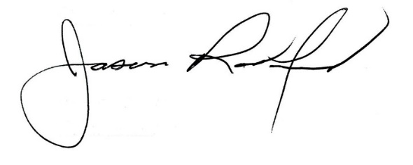

Carley Clemm, Board Chair Jason Radford, Superintendent/Secretary

