CONSENT ITEM I
June 9, 2025
OLDHAM COUNTY BOARD OF EDUCATION
CONCERN
Update to the 2025-2026 Certified Evaluation Plan.
DISCUSSION
This past legislative session, House Bill 48 was passed and signed by the Governor on 4/1/2025. The new legislation changes the length of time that a certified tenured staff member will receive a summative evaluation. The legislation extends the summative evaluation period from every three years to every five years.
The district CEP task force reviewed both the current CEP plan and the revised version and agreed that the only necessary change is to update the frequency of summative evaluations for tenured teaching staff from every three years to every five years.
See the attached CEP.
RECOMMENDATION
Approve the 2025-2026 Certified Evaluation Plan with the update from three years for certified tenured staff to meet the language of the new legislation moving the summative to every five years.

Motion Passed: Consent Agenda passed with a motion by _______________, seconded by _______________, the Board approved the 2025-2026 Certified Evaluation Plan with the update from three years for certified tenured staff to meet the language of the new legislation moving the summative to every five years. ( ,)

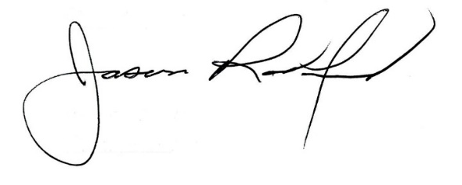

Carly Clem, Board Chair Jason Radford, Superintendent/Secretary

