CONSENT ITEM H
June 9, 2025
OLDHAM COUNTY BOARD OF EDUCATION
CONCERN
Consider Approval of Bids for Diesel Fuel and Gasoline for July 2025 through June 2026.
DISCUSSION
Our Transportation Department advertised for competitive bids for diesel fuel and gasoline for the coming school year on May 15th, 2025. Our bid specifications did not ask vendors to quote a specific fixed price per gallon for diesel fuel or gasoline. Instead, we have requested bids for the mark-up or differential per gallon that would be added to the Oil Price Information Service (OPIS) rack price that is established by the regional oil terminals each day. Our price will fluctuate as the rack price varies, but the mark-up on each gallon will be fixed.
We asked for differential per gallon bids for unleaded gasoline, 5% biodiesel blend, and 5% biodiesel blend with winter additive. We recommend awarding gasoline and diesel separately with the winning bid for biodiesel going to the vendor with the lowest average differential between biodiesel and biodiesel with winter blend. Bids for the period starting July 1, 2025, to June 30, 2026, were opened on May 30, 2025. Immediately following this enclosure, you will find the bid tally sheet with the bids offered by the three (3) vendors who responded: Mansfield Oil Company, Petroleum Traders Corporation and Valor Oil LLC.
RECOMMENDATION
For the period from July 1, 2025 through June 30, 2026, approve the award of the bid for diesel fuel to Petroleum Traders Corporation at $0.0016 (0.16 cents) per gallon above the OPIS average for # 2 diesel and $0.0216 (2.16 cents) per gallon above the OPIS average for # 2 diesel with winter additive with an average differential for both products of $0.0116 (1.16 cents) per gallon above the OPIS rack average price. Also, for the same period, approve the award of the bid for unleaded gasoline to Petroleum Traders Corporation at a differential of -$0.0089 (-0.89 cents) per gallon below OPIS rack average price.

Motion Passed: Consent Agenda passed with a motion by _______________, seconded by _______________, the Board approved the award of the bid for diesel fuel to Petroleum Traders Corporation at $0.0016 (0.16 cents) per gallon above the OPIS average for # 2 diesel and $0.0216 (2.16 cents) per gallon above the OPIS average for # 2 diesel with winter additive with an average differential for both products of $0.0116 (1.16 cents) per gallon above the OPIS rack average price. Also, for the same period, approve the award of the bid for unleaded gasoline to Petroleum Traders Corporation at a differential of -$0.0089 (-0.89 cents) per gallon below OPIS rack average price
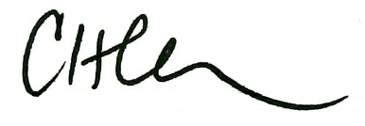
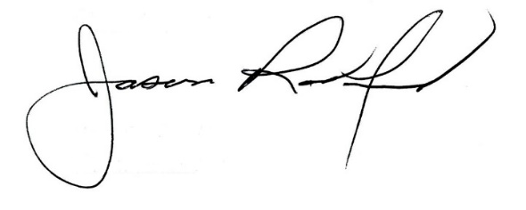

Carly Clem, Board Chair Jason Radford, Superintendent/Secretary

