CONSENT ITEM G
June 9, 2025
OLDHAM COUNTY BOARD OF EDUCATION
CONCERN
The 2025-2026 salary schedules presented earlier this spring contained a few errors and/or omissions that need to be corrected.
DISCUSSION
- The salary schedule for Guidance Counselors hired prior to FY23 grade 21 needs to be corrected. A previous year’s column was inadvertently attached vs the new 2025-26 column. The updated schedule is attached.
- The salary schedule for Director of Nursing was updated during the 2024-25 school year with an increase of 15 days. However, due to the school year already starting, we agreed to pay the fifteen days by board standard invoice for the remainder of the 2024-25 school year and correct the salary for the 2025-26 school year. At the time of updates, it was overlooked, and the approved salary schedule was still based off of 200 days not the 215 days. See the updated schedule attached.
- Updated language at the bottom of the substitute teacher pay scale to reflect changes to rank and incentives. There was no change in the pay amount.
RECOMMENDATION
Approve the updated Guidance Counselor salary schedule for staff hired prior to FY23 in grade 21, the updated Director of Nursing salary schedule to reflect the 215 days salary and approve the updated language at the bottom of the substitute salary schedule.

Motion Passed: Consent Agenda passed with a motion by _______________, seconded by _______________, the Board approved the updated Guidance Counselor salary schedule for staff hired prior to FY23 in grade 21, the updated Director of Nursing salary schedule to reflect the 215 days salary and approve the updated language at the bottom of the substitute salary schedule. ( , )
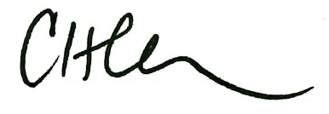
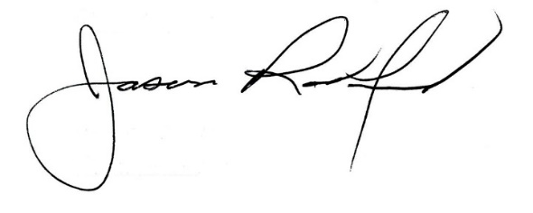

Carly Clem, Board Chair Jason Radford, Superintendent/Secretary

