CONSENT ITEM F
June 9, 2025
OLDHAM COUNTY BOARD OF EDUCATION
CONCERN
Consider Approval of 2025 High School Graduates from Liberty Academy, Buckner Alternative High School, North Oldham High School, Oldham County High School, and South Oldham High School
DISCUSSION
The District had another successful year graduating seniors from our five high schools. Following this enclosure are the lists of graduates from each high school.
RECOMMENDATION
Approve the graduating seniors for the Class of 2025.

On a motion by _______________, seconded by Choose an item., the Board approved the graduating seniors for the Class of 2025. ( , )


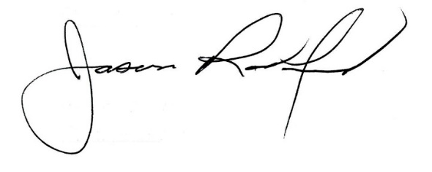

Carly Clem, Board Chair Jason Radford, Superintendent/Secretary

