CONSENT ITEM A
June 9, 2025
OLDHAM COUNTY BOARD OF EDUCATION
CONCERN
Consider Approval of Field Trips Requesting Overnight Stay & Field Trips Requesting Use of Common Carrier.
DISCUSSION
The following are field trips requesting overnight stay and trips requesting use of a common carrier:
SCHOOL | GROUP | LOCATION/DATE | JUSTIFICATION | INSTR. DAYS LOST
NOHS | Boy/Girl Tennis | Lexington, KY  May 26-29, 2025 | Overnight: State Championship  Parents | 2
NOHS | Boy/Girl Tennis | Lexington, KY  June 3-4, 2025 | Overnight: State Championship  Parents | 0
EOMS | Cheer | UK  July 27-29, 2025 | Overnight: Summer Camp  Parents | 0
OCMS | Cheer | Mason OH  June 16-19, 2025 | Overnight: Summer Camp  Parents | 0
SOHS | Band | Orlando FL  Feb 11-16, 2026 | Overnight:  Charter Bus | 2
NOMS | Club Atlas | Washington, DC  April 28-30, 2026 | Overnight: Historical Trip  Air | 3
OCMS | ELL | Cahokia Mounds, IL  July 10-11, 2025 | Overnight:  Bus | 0
Approve the field trips as attached and described above, pursuant to the condition that students not traveling on school buses, with their parents, or with a Board employee whose insurance carrier has named OCBE as an additional named insured, will be transported to and from their destination on an approved charter bus(es) and school(s) shall obtain written evidence of liability.

Motion Passed: Consent Agenda passed with a motion by _______________, seconded by _______________, the Board gave approval of the field trips as attached and described above, pursuant to the condition that students not traveling on school buses, with their parents, or with a Board employee whose insurance carrier has named OCBE as an additional named insured, will be transported to and from their destination on an approved charter bus(es) and school(s) shall obtain written evidence of liability. ( , )
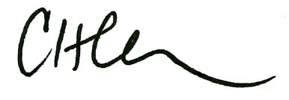
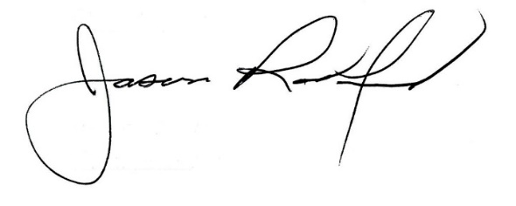

Carly Clem, Board Chair Jason Radford, Superintendent/Secretary

