OLDHAM COUNTY BOARD OF EDUCATION
SPECIAL CALLED MEETING
May 30, 2025
Oldham County District Office
6165 W HWY 146, Crestwood, KY 40014
Attendance Taken at: 2:08 PM
Present Board Members:
Mrs. Suzanne Hundley
Ms. Carly Clem
Ms. Allison Sheffer
Mr. Adam Springer
- CALL MEETING TO ORDER
Chairperson Clem called the meeting to order at 2:08 pm.
- APPROVE AGENDA
Motion Passed: Approval of the Agenda passed with a Motion by Suzanne Hundley, seconded by Allison Sheffer. 4 Yeas - 0 Nays.
- EXECUTIVE SESSION
Motion Passed: Approval to enter into Executive Session @ 2:10 pm pursuant to pursuant to KRS 61.810(1)(f) - Discussions or hearings which might lead to the appointment, discipline, or dismissal of an individual employee, member, or student without restricting the employee's, member's, or student's right to a public hearing if requested. This exception shall not be interpreted to permit discussion of general personnel matters in secret passed with a motion by Suzanne Hundley, seconded by Allison Sheffer.
4 Yeas - 0 Nays
The board returned to regular session at 3:37 pm. The following action was taken coming out of executive session.
“The Board has returned from Executive Session, during which the Board discussed the selection of the next District’s next superintendent. Prior to taking any action, I would like to thank my fellow Board members and members of the Superintendent Screening Committee for all their work getting us to this point. I would also like to thank Don Martin and KSBA for their assistance during this process.
Selecting a new superintendent is one of the most important, and difficult decisions that the Board of Education makes for the District. We not only consider the current needs of the District, but also the long-term future of our District in finding a candidate with the right experience and abilities to best meet those needs. It is a lengthy and tedious evaluation process for both the candidates and the Board, but we are committed to taking the steps necessary to hire the right candidate.
I move that the Oldham County Board of Education extend an offer of employment as superintendent of Oldham County Schools, on the terms and conditions to be agreed upon prior to the June 9, 2025 regularly scheduled board meeting.
On a motion by Suzanne Hundley, seconded by Allison Sheffer, the Board agreed to extend an offer of employment as superintendent of Oldham County Schools, on the terms and conditions to be agreed upon prior to the June 9, 2025 regularly scheduled board meeting. (3,1) Adam Springer opposed.

- ADJOURN
With no further business to discuss, Chairperson Clem called for a motion and second to adjourn. On a motion by Allison Sheffer, seconded by Suzanne Hundley, the Board adjourned the special called meeting at 9:00 p.m. 4 Yeas - 0 Nays

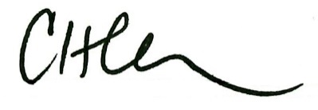
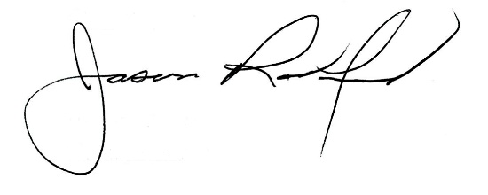

Carly Clem, Board Chair Jason Radford, Superintendent/Secretary

