OLDHAM COUNTY BOARD OF EDUCATION
SPECIAL CALLED MEETING
May 22, 2025
Oldham County District Office
6165 W HWY 146, Crestwood, KY 40014
Attendance Taken at: 5:00 PM
Present Board Members:
Mrs. Suzanne Hundley
Ms. Carly Clem
Ms. Allison Sheffer
Mr. Adam Springer
- CALL MEETING TO ORDER
Chairperson Clem called the meeting to order at 5:00 pm.
- APPROVE AGENDA
Motion Passed: Approval of the Agenda passed with a Motion by Adam Springer, seconded by Suzanne Hundley. 4 Yeas - 0 Nays.
- EXECUTIVE SESSION
Motion Passed: Approval to enter into Executive Session @ 5:01 pm pursuant to pursuant to KRS 61.810(1)(f) - Discussions or hearings which might lead to the appointment, discipline, or dismissal of an individual employee, member, or student without restricting the employee's, member's, or student's right to a public hearing if requested. This exception shall not be interpreted to permit discussion of general personnel matters in secret passed with a motion by Suzanne Hundley, seconded by Allison Sheffer.
4 Yeas - 0 Nays
The board returned to regular session at 8:59 pm.
- ADJOURN
With no further business to discuss, Chairperson Clem called for a motion and second to adjourn. On a motion by Suzanne Hundley, seconded by Allison Sheffer, the Board adjourned the special called meeting at 9:00 p.m. 4 Yeas - 0 Nays

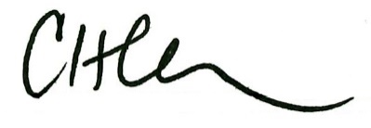
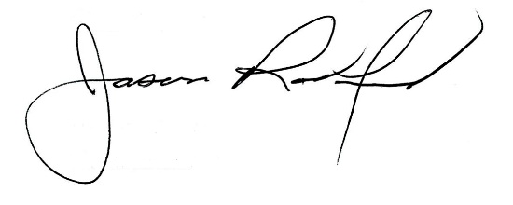

Carly Clem, Board Chair Jason Radford, Superintendent/Secretary

