OLDHAM COUNTY BOARD OF EDUCATION
SPECIAL CALLED MEETING
June 4, 2025
ARVIN EDUCATION CENTER
1650 Colonels Drive, La Grange, KY 40031
Attendance Taken at: Noon PM
Present Board Members:
Mrs. Suzanne Hundley
Ms. Carly Clem
Ms. Allison Sheffer
Mr. Adam Springer
- CALL MEETING TO ORDER
Chairperson Clem called the meeting to order at 12:00 pm.
- APPROVE AGENDA
Motion Passed: Approval of the Agenda passed with a Motion by Allison Sheffer, seconded by Suzanne Hundley. 4 Yeas - 0 Nays.
- SUPERINTENDENT REPORT
The board discussed a possible waiver to policy concerning experience awarded to employees.
- EXECUTIVE SESSION
Motion Passed: Approval to enter into Executive Session @ 12:02 pm pursuant to pursuant to KRS 61.810(1)(f) - Discussions or hearings which might lead to the appointment, discipline, or dismissal of an individual employee, member, or student without restricting the employee's, member's, or student's right to a public hearing if requested. This exception shall not be interpreted to permit discussion of general personnel matters in secret passed with a motion by Suzanne Hundley, seconded by Allison Sheffer.
4 Yeas - 0 Nays
The board returned to regular session at 12:13 pm. The following action was taken coming out of executive session.
Chairman Carly Clem made the following statement: “The Board has returned from Executive Session, during which the Board discussed the selection of the next District’s next superintendent.
On a motion by Carly Clem, the Oldham County Board of Education has entered a contract of employment as Superintendent of Oldham County Schools with Claudette Herald. (3,1) Adam Springer opposed.
- ADJOURN
With no further business to discuss, Chairperson Clem called for a motion and second to adjourn. On a motion by Suzanne Hundley, seconded by Allison Sheffer, the Board adjourned the special called meeting at 12:14 pm. 4 Yeas - 0 Nays


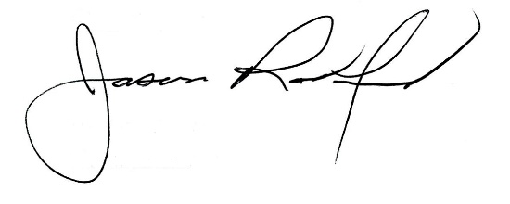

Carly Clem, Board Chair Jason Radford, Superintendent/Secretary

