EXECUTIVE SESSION
June 4, 2025
OLDHAM COUNTY BOARD OF EDUCATION
CONCERN
Consider Executive Session pursuant to KRS 61.810(1)(f) - Discussions or hearings which might lead to the appointment, discipline, or dismissal of an individual employee, member, or student without restricting the employee's, member's, or student's right to a public hearing if requested. This exception shall not be interpreted to permit discussion of general personnel matters in secret.
DISCUSSION
At this time, I need a motion to go into Executive Session pursuant to KRS 61.810(1)(f) - Discussions or hearings which might lead to the appointment, discipline, or dismissal of an individual employee, member, or student without restricting the employee's, member's, or student's right to a public hearing if requested. This exception shall not be interpreted to permit discussion of general personnel matters in secret.
RECOMMENDATION
Conduct Executive Session.

On a motion by _______________, seconded by _______________, the Board entered into Executive Session pursuant to KRS 61.810(1)(f) - Discussions or hearings which might lead to the appointment, discipline, or dismissal of an individual employee, member, or student without restricting the employee's, member's, or student's right to a public hearing if requested. This exception shall not be interpreted to permit discussion of general personnel matters in secret @ ____ pm ( , )

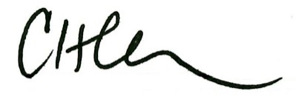
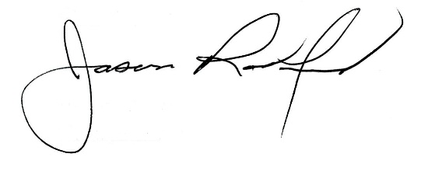

Carly Clem, Board Chair Jason Radford, Superintendent/Secretary

