Strategic Prevention Framework
I³: Inspired, Individualized, Inclusive
April 2025 - May 2025
Goal: To reduce the onset & progression of substance misuse & its related problems in Bellevue, KY, by supporting the development & delivery of community substance misuse prevention & mental health promotion services.
Objective 1: | By 9/29/2027, reduce the 30-day use of alcohol among tenth-grade students by 2% each year as measured by annual KIP survey data.
Objective 2: | By 9/29/2027, reduce regular (30-day) vaping use among tenth-grade students by 2% each year as measured by annual KIP survey data.
Objective 3: | By 9/29/2027, reduce regular (30-day) cigarette smoking among tenth-grade students by 2% each year as measured by annual KIP data.
Objective 4: | By 9/29/2027, tenth-grade students reporting serious psychological distress, according to the K6 KIP data, will decrease by 4% each year.
Objective 5: | By 9/29/2027, expand collaboration with community prevention partners, demonstrated by support from community prevention partners at least 2x each year in the project’s family prevention education opportunities, documented by photographic evidence & meeting notes.

ASSESSMENT
Accomplishments | Description |  |  |  | Align
Specification of baseline data: | Teacher-rated SEB screeners were sent to all educators to rate student behavior for grades K-5 and 6-12. The data used within the MTSS framework to proactively detect students who need support.  - GES Spring 24-25 Universal Screening  - 194 students rated in total  - 231 students enrolled  - BMHS Spring 24-25 Universal Screening  - 91 students rated in total  - 293 students enrolled |  |  |  | 1-4
Monitoring school needs assessment activities:  BMHS MTSS Tracker  GES MTSS Tracker | Internal Referrals for mental health services.  0 internal referrals for services (GES only)  0 internal referral accepted  0 internal referral in progress  19 students fading out of services  1 internal referral for prevention services  0 internal referral assessments completed for prevention services |  |  |  | 1-4
Monitoring schools needs assessment activities: | External Referrals for mental health & prevention services. *  2 student/family external referral  0 student/family Care Solace referrals  0 staff member's Care Solace referrals  20 external resources distributed  *Specific BMHS external referral data unknown |  |  |  | 1-4
Monitoring schools needs assessment activities:  SPF Outreach Data | Grant staff collect & monitor data on all grant lead initiatives. This includes, but is not limited to: |  |  |  | 1-5
 | - Outreach & Engagement Data  - Participation Data  - Outcome Data | - Financial Data  - Progress Monitoring
CAPACITY
Accomplishments | Description |  |  |  | Align
Professional Development: | SPF Grant Staff:  - Recognizing the Signs: Equipping Educators to Prevent and Respond  - UK - Skills for Psychological Recovery  - 2025 Adult Allies Learning Series  - Character Strong Leading Safe, Supportive, and Responsive School Systems  - Navigators of the Commonwealth - UK Center on Trauma and Children  - CareSolace: End of Year Check-in Call |  | - SPTAC Regions III and IV: Listening Session  - CareSolace Seasonal Training  - UK - Trauma-Informed Care  - Professional Resilience: Ethics and Self-Care  - Rising Minds: Shaping the Future of Youth Wellness  - KPN Conference  GES Mental Health Professional:  - The Body Keeps the Score (trauma training)  - National Mental Health Conference (NatCon 2025) |  | 5
Building internal coalitions: | Grant staff participated in the following monthly coalition/committee meetings: |  |  |  | 5
Building internal coalitions: | - GES Student Care Team Meeting  - GES Arc Meeting | - Rae of Sunshine - SMILE Club Meetings  - Mental Health & Prevention Staff & Treatment
Building external coalitions: | Grant staff participated in the following monthly coalition/committee meetings: |  |  |  | 5
Building external coalitions: | - NKY ASAP  - SBMH Grant Committee Meeting  - TISS Grant Committee Meeting  - Youth Summit Planning Committee | - NKISP Steering Committee Meeting  - Campbell County Drug-Free Alliance General Meeting  - River Cities Drug-Free Coalition Meeting  - Adult Allies
Building external partnerships: | Grant staff meet with the following community agencies: |  |  |  | 5
Building external partnerships: | - North Key – Too Good for Drugs Curriculum  - NKY Health Department – Too Good for Drugs  - Character Strong  - Care Solace  - SAMHSA – SPF Carryover discussion | - Kroger  - Trader Joe  - Starbucks  - NKCES – Mental Health Roundtable  - Perfetti Van Mel – May Mentos Moment Initiative
Community Conversations: | - North Key – TGFD Curriculum  - CCDFA to discuss video campaign |  |  |  | 5
Other infrastructure development: | - Review & update the MH&Prevention Webpage with resources weekly  - BISD Resource Mapping review & update support for students, staff, & families |  |  |  | 5
PLANNING
Accomplishments | Description |  |  |  | Align
Articulation of a vision for prevention activities: | Grant staff are working toward planning the following: |  |  |  | 1-4
Articulation of a vision for prevention activities: | MAY  - Weekly Rae of Sunshine – SMILE Club  - 05/01 – Daily Mental Health Social Media Campaign  - 05/15 - Mental Health Day of Action Day  - 05/15 – GES Field Day  - 05/15 – SMILE Club Awards  - 05/16 – Prevention Newsletter  - 05/20 – SPF Grant Advisory Board Meeting  - 05/27 – Smile Club - Chalk the Walk  JUNE/JULY  - 06/05 - Character Strong Training  - Trauma Plan Review  - Prevention Plan Review  - MTSS Process Review | - Mental Health & Prevention Services Handbook & Procedure Review  - SPF Documentation & Planning  - Too Good for Drugs Curriculum with Health Department & North Key  - SMILE Club  AUGUST  - Back-to-School Bash  - Prevention one-pager for all district families  FALL  - Dinner Table Project 25-26  - Suicide Prevention Awareness  - World Mental Health Day  - Red Ribbon Week |  |  | 1-4
IMPLEMENTATION
Accomplishments | Description |  |  |  | Align
Specific community-level interventions being implemented: | Grant staff implemented the following:
Specific community-level interventions being implemented: | APRIL  - 04/15 – Dinner Table Project #4  - 04/15 – SMILE Club  - 04/16 – Skills for Psychological Recovery  - 04/18 – Spill the Tea  - 04/22 - Planting Kindness on Earth Day  - 04/23 - S.M.I.L.E. Club Article  - 04/24 - SMILE Club Positivity Plant Pet Delivery (Middle School Teachers/Classrooms)  - 04/28 - DeStress Monday – Social Media Campaign  - 04/29 - 04/30 – KPN 2025 Spring Training | - 04/29 – KPN: Supporting School Districts with HB 142  - 04/29 – KPN: Youth Voices-Safe and Healthy Choices  - 04/30 – KPN: Consequences of Co-Use of Nicotine & Cannabis  - 04/30 – KPN: Legislative Updates on Medical Cannabis  - 04/30 – Navigators of the Commonwealth  - 04/30 – Care Solace in of the year check in  MAY  05/01 - Mental Health Month Social Media Awareness Campaign  05/01 - May Mentos Mindful Moments Initiative  05/01 - NKY Student Mental Health Roundtables
Specific community-level interventions being implemented: | Planting Kindness on Earth Day  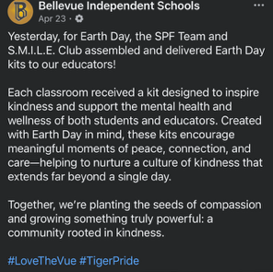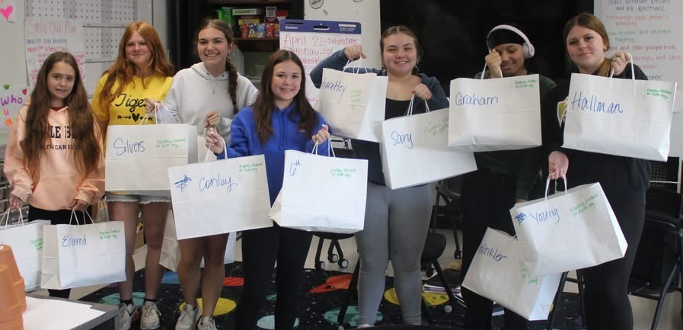  SMILE Club Positivity Plant Pet Delivery  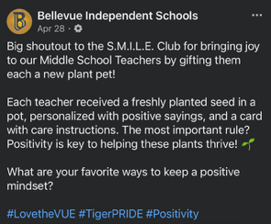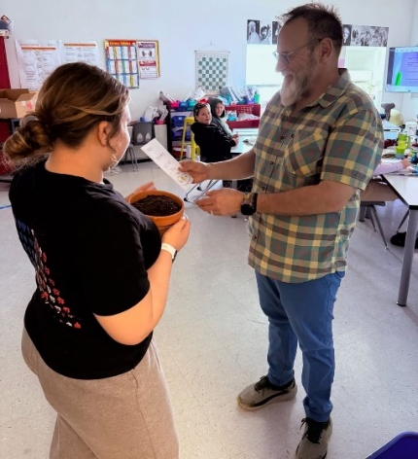  NKY Student Mental Health Roundtables  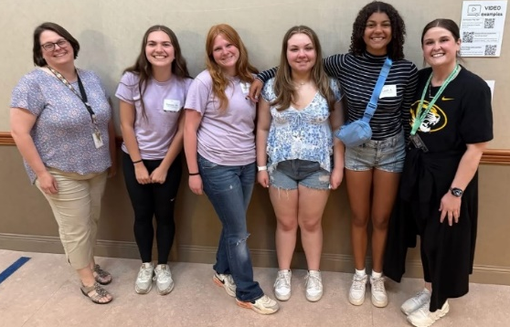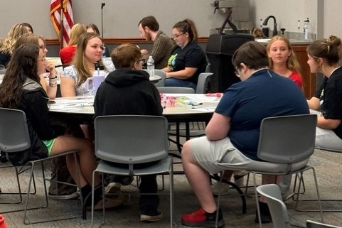  May Mentos Mindful Moments Initiative  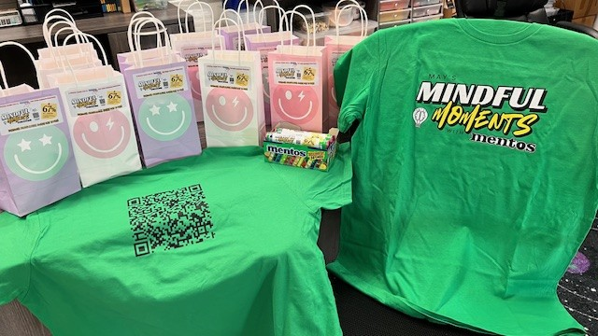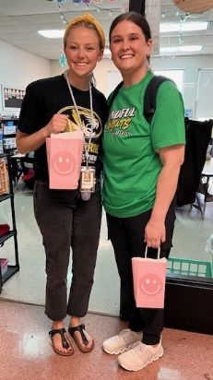
Implemented policies within organizations to facilitate interventions | Grant staff works with the following grants to create procedures for the BISD mental health & prevention team in response to students' & families' mental health & prevention needs. These align with best practices.  - Trauma-Informed Grant  - Grant staff continues to work with TISS Grant to revise BISD’s trauma-informed plan & create action steps to ensure the implementation of best practices.  - Grant staff continues to work with SBMH Grant to review & revise BISD’s Mental Health plan & create action steps to ensure the implementation of best practices.  - School-Based Mental Health Grant  - Grant staff continues to work with SBMH Grant to review & revise BISD’s Mental Health plan & create action steps to ensure the implementation of best practices.  - Prevention  - Grant staff continues to review & revise BISD’s Prevention plan, creating action steps to ensure the implementation of best practices.  - Created district tobacco/nicotine-free procedure in response to HB-142; the procedure was added to the Code of Conduct and middle/high school behavior matrix. |  |  |  | 4
Specific community-level interventions being implemented: | SBMH Breakdown of time and/or student reached/seen:  - Direct: 2,320 minutes = 38.7 hours  - Total Sessions: 58  - Extra Sessions: 2; 25 minutes  - Indirect: 1,280 minutes = 21.3 hours |  |  | SBMH GES Caseload Numbers:  - Active cases: 19  - Tier 2 performance: 0  - Referrals: 2  - Total referred, awaiting consent in last month: 1  - Total fading out of services in last month: 3 | 4
Specific community-level interventions being implemented: | Prevention Breakdown of time and/or student reached/seen:  - Total sessions: 20  - Total direct sessions: 15  - Total extra sessions: 5  - Groups: 0  - Tier 2 performance: 0 |  |  | Prevention Caseload Numbers:  - Active cases: 8  - Referrals: 5  - Pending: 0  - Tier 2 performance: 0 | 1-4
Developed systems for distributing resources: | 0 lockboxes distributed to families  - 22 distributed in total |  |  | 0 Deterra bags distributed to families  - 0 distributed in total  - 75 available | 1-3
EVALUATION
Accomplishments | Description |  |  |  | Align
Monitor & evaluate all activities: | Evaluating SEB tier 1/2 data collected to support and inform our developing MTSS  - SPF worked with educators in both buildings to increase the completion rate of universal screening assessments  - Increase in BMHS completion rate; 0 students rated during WI24 screening to 91 students rated during SP25  - 0% to 31%  - 194 student ratings completed for grades K-5 at GES  - SPF worked with GES educators on defining and collecting data |  |  |  | 4
Monitor & evaluate all activities: | Evaluating tier 3 school-based mental health services at GES by using Child Outcome Rating Scale (CORS) and Child Session Rating Scale (CSRS). These tools measure progress made in therapy sessions. Progress monitoring should be reviewed and utilized at Tier 2/3 Meeting. |  |  |  | 4
Monitor & evaluate all activities: | SPF Outreach Data  - Outcome data collected on the number of event impressions and post-survey information  - Data submitted to SPARS  3,919 TOTAL SERVED  Direct service or interaction with student, staff, family member, or community member  35,136 TOTAL INTERACTION  Indirect, organic reach for social media post  105,075 TOTAL REACH  Indirect, count of times content is displayed or viewed across all platforms  Recent Implementation:  Earth Day “Planting Seeds of Kindness Kits” (S.M.I.L.E. Club) = 1495 reach, 721 interactions, 38 served  Plant Pets for Middle School Teachers (S.M.I.L.E. Club) = 1062 reach, 540 interactions, 22 served  Dinner Table Project = 20 families, 100 family members, 41 students  DeStress Mondays = 2743 reach, 1658 interactions, 7 served  Ongoing Implementation:  Dinner Table Project = 10830 reach, 2946 interactions, 866 served  Spill the Tea = 7766 reach, 1654 interactions, 37 served  Lockboxes = 23 served |  |  |  | 1-5
Monitor & evaluate all activities: | Tracking the occurrence of substance use related office referrals at BMHS since the beginning of the grant; overall, we continue to see a decrease in substance use related office referrals.  SUD Behavior Office Referral Data |  |  |  | 1-3
Monitor & eval activities: | #iCANendthetrend post-surveys completed; waiting to receive data to review from the program. |  |  |  | 1-5
Monitor & evaluate all activities: | Creating process to evaluate outreach data and increased prevention messaging data for this academic year to inform decisions and initiatives for next academic year. |  |  |  | 1-5
Grant Reporting: | - 12/31 – SPF eRa Commons Annual Performance Review – Under Review  - 01/31 – SPF Continuation Report – Under Review  - 04/15 – SPF eRa Commons Carryover – Approved  - 05/05 – Annual Target Report – Submitted  - 05/26 – SPF SPARS Quarter 1 Report – Due  - 06/23 – SPF SPARS Quarter 2 Report – Due |  |  |  | 1-5

SUSTAINABILITY
Sustaining infrastructure: | Continue developing & improving the district's MTSS system & mental health support.

Data utilization for GES & BMHS unknown
According to Infinite Campus enrollment report
According to Infinite Campus enrollment report
Specific BMHS mental health referral data and internal referral assessments unknown

