THIS IS A DECISION PAPER
TO: HARDIN COUNTY BOARD OF EDUCATION
FROM: Teresa Morgan, Superintendent
DATE: May 15, 2025
SUBJECT: Construction Services for a New North Park Elementary
FACTS:
District officials reviewed the performance of our current Construction Managers, Codell and WEHR, and conducted corresponding interviews with both firms. Both projects they are overseeing for the district appear to be going well at the current time.
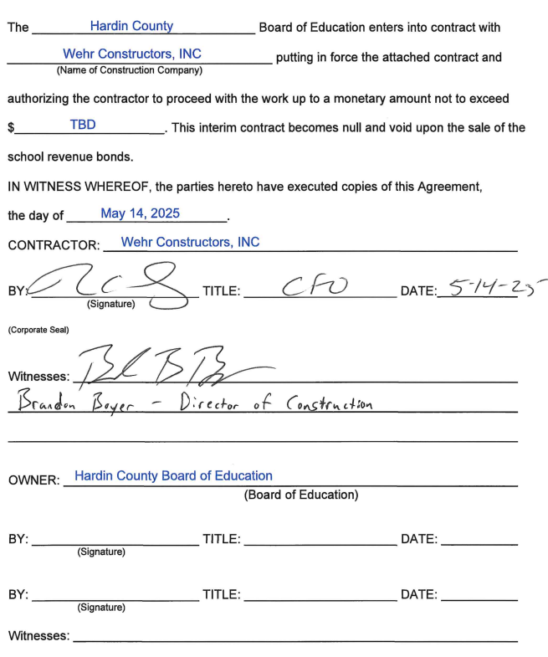
*See attached contract
RECOMMENDATION
I RECOMMEND THE BOARD APPROVE AN INTERIM CONSTRUCTION MANAGER CONTRACT WITH WEHR FOR THE NEW NORTH PARK ELEMENTARY PROJECT
RECOMMENDED MOTION
I MOVE THAT THE HARDIN COUNTY BOARD OF EDUCATION APPROVE AN INTERIM CONSTRUCTION MANAGER CONTRACT WITH WEHR FOR THE NEW NORTH PARK ELEMENTARY PROJECT.

