ACTION ITEM D
May 19, 2025
OLDHAM COUNTY BOARD OF EDUCATION
CONCERN
Consider Approval of the amended FY25 Board Meeting Schedule.
DISCUSSION
The June 23, 2025, regular board meeting date will be amended to June 9, 2025.
All other dates will remain the same.
Regular Session Dates:
- Monday, June 23, 2025 Amend to June 9, 2025
RECOMMENDATION
Approve the FY25 Regular Board Meeting amended schedule as presented.

On a motion by _______________, seconded by _______________, the FY25 Regular Board Meeting amended schedule as presented. ( , )

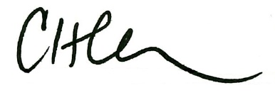
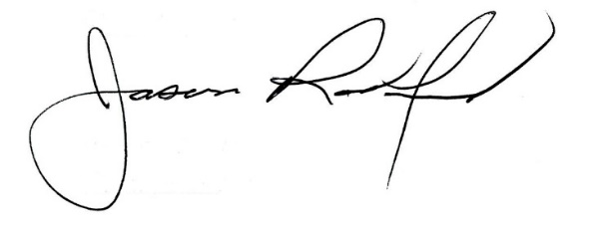

Carly Clem, Board Chair Dr. Jason Radford, Superintendent/Secretary

