ACTION ITEM C
May 19, 2025
OLDHAM COUNTY BOARD OF EDUCATION
CONCERN
Consider School Budgets for FY 2025-2026
DISCUSSION
Each year the principals are directed to prepare a detailed budget for their school activity accounts. The process is to begin with the teachers in grade level or departmental group(s) developing their annual budget for instructional materials and supplies, and ends, at the school level, with site-based council approvals. These detailed documents are then submitted to the Superintendent for review with recommendations made to the Board for Board appropriations to support instructional activities in the schools.
The following enclosure summarizes the amounts requested in the various school and daycare budgets. The total projected revenue for all the schools for 2025-2026 is $20,298,520 including daycare. This is a $1,386,479 increase from last year’s budget projections. No school will end the FY25 school year with a negative balance in either activity funds or daycare funds in accordance with District guidelines. The detailed Budget Summaries for each school are included as part of this enclosure.
RECOMMENDATION
The recommendation is for the Board to approve school budgets for FY 2026 in the amounts listed in this enclosure. Administrative policy requires the funds must be expended pursuant to the approved budget in the specific code where approved, unless approved in writing by the Superintendent for transfer to another fund.

On a motion by _______________, seconded by _______________, the Oldham County Board of Education approved the school budgets for FY 2026 in the amounts listed in this enclosure. ( , ).

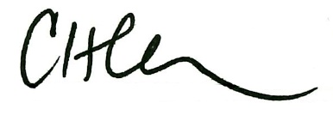
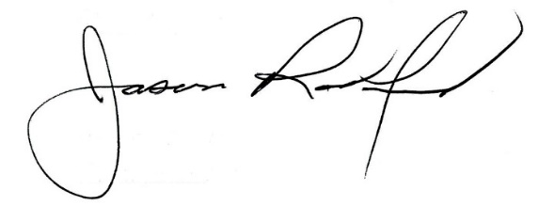

Carly Clem, Board Chair Dr. Jason Radford, Superintendent/Secretary

