ACTION ITEM B
May 19, 2025
OLDHAM COUNTY BOARD OF EDUCATION
CONCERN
Consider approval of Tentative Working Budget for fiscal year 2025-26.
DISCUSSION
The draft working budget for 2025-26 was approved by the Board in January. The tentative working budget for the upcoming fiscal year must be completed and approved by the Board for submission to the Kentucky Department of Education by May 30 of the current fiscal year.
The tentative working budget includes a 5% annual raise and step increase for all certified and salary staff and a $2 per hour increase for all hourly classified staff, as was approved by the Board in April.
Also, included is the following:
- Certified Bump in Salary Schedule (0-3) plus extend to 33 years $3,570,721.00
- Reduce Barriers for at Risk Students $270,000.00
- Additional Middle School Teacher allocation $450,000.00
- Middle School Curriculum- CTE curriculum tools, & furniture $450,000.00
- Parent Fee Reduction-$40 per student $415,180.00
- Stipends-$250 increase per stipend $220,000.00
- Special Class Recruitment and Retention $665,000.00

The Final Working Budget will be completed by September 30 after proper assessments and tax rates are received.
RECOMMENDATION
Approve the Tentative Working Budget for Fiscal Year 2025-26 for submission to the Kentucky Department of Education.

On a motion by _______________, seconded by _______________, the Oldham County Board of Education approved the Tentative Working Budget for Fiscal Year 2025-26 for submission to the Kentucky Department of Education. ( , ).

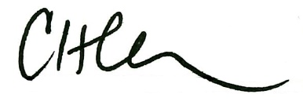
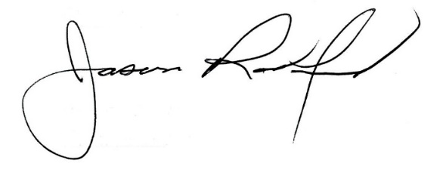

Carly Clem, Board Chair Dr. Jason Radford, Superintendent/Secretary

