ACTION ITEM A
May 19, 2025
OLDHAM COUNTY BOARD OF EDUCATION
CONCERN
Consider approval of requested Policy Revisions.
DISCUSSION
Consider Approval of policy revisions. These revisions were presented at the April Regular Board Meeting.
NUMBER | NAME OF POLICY | REASON FOR AMENDMENT/ADDITION
Policy – 1st read
M03.12322  M03.22322 | Personnel – Leave Policy Certified and Classified. | The change requires employees, both certified and classified, going out on leave to use all available paid days before going taking leave without pay.
BE03.125 | Finance – Expense Reimbursement Certified | Update to remove the word “meal” and replaced with “diem”. This will take care of any questions about how the meal reimbursements will be paid. They will be paid a flat rate per diem and not require any receipts.
M03.225 | Finance – Expense Reimbursement Classified | Update the classified (03.225) to match the certified. It still had the original language of per diem, but was 40.00 and 50.00 per day

RECOMMENDATION
Approve the policy revisions as presented.

On a motion by _______________, seconded by _______________, the Board approved the policy revisions as presented. ( , )

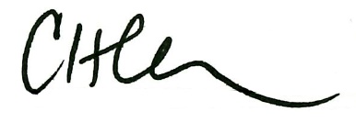
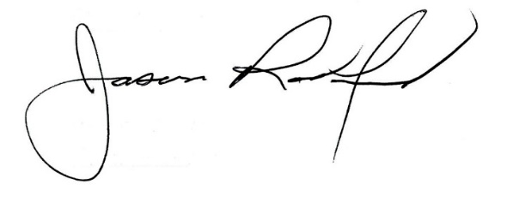

Carly Clem, Board Chair Dr. Jason Radford, Superintendent/Secretary

