CONSENT ITEM H
May 19, 2025
OLDHAM COUNTY BOARD OF EDUCATION
CONCERN
Approve the NSLP (National School Lunch Program) and SBP (School Breakfast Program) meal prices for SY 2025/2026.
DISCUSSION
OCSN student meal prices have not been increased since 2022. KDE is still awaiting guidance from USDA on the Paid Lunch Equity Tool (PLE) that is used to determine pricing. The PLE from last year showed a meal price recommendation of $3.75. We obtained a waiver and did not increase pricing. We will not qualify for the waiver this year. No more than a $0.10 increase has been required in the past, but due to the increasing cost of meal production we are recommending a $0.20 meal price increase.
Elementary School
NSLP Paid: $2.60 SBP Paid: $1.50
Reduced: $0.40 Reduced: $0.30
Middle/High School
NSLP Paid: $3.05 SBP Paid: $1.50
Reduced: $0.40 Reduced: $0.30
Adult Breakfast: $3.10 Adult Lunch: $5.05
RECOMMENDATIONS
Approve the proposed FY26 NSLP and SBP meal prices.

On a motion by _______________, seconded by _______________, the Board approved the proposed FY26 NSLP and SBP meal prices. ( , )
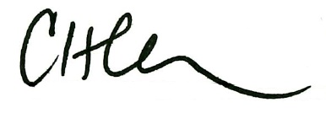
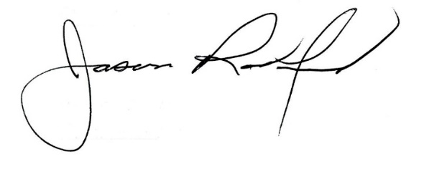

Carly Clem, Board Chair Dr. Jason Radford, Superintendent/Secretary

