CONSENT ITEM I
May 19, 2025
OLDHAM COUNTY BOARD OF EDUCATION
CONCERN
To review and approve the current District Wellness Policy in accordance with KRS 160.345 and Board Policy 02.4241
DISCUSSION
The Superintendent or representative is required to submit a wellness plan that includes a summary of the findings and recommendations of the nutrition and physical activity report each year to the Kentucky Department of Education (KDE). (702 KAR 6:090 Section 5 (1,c) / Section 6 (2)). The District shall include within the findings and recommendations the following:
- Extent to which the District is in compliance with this Policy;
- A comparison of how the District measures up to model wellness policies provided by recognized state and national authorities; and
- A description of the measurable progress made towards reaching goals of the District wellness policy and addressing any gaps identified in the wellness report for the previous year.
RECOMMENDATION
To approve the Local Wellness Policy for the 2025/2026 school year.

On a motion by _______________, seconded by _______________, the Board approved the Local Wellness Policy for the 2025/2026 school year. ( , )
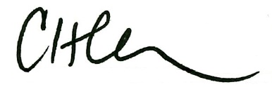
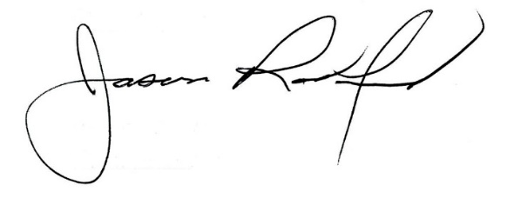

Carly Clem, Board Chair Dr. Jason Radford, Superintendent/Secretary

