

Dawson Springs Elementary School
Where the teachers and students give 100% every day and failure is not an option.
Panthers Prowling to Proficiency!

May 2025 Board Meeting
Elementary Principal Report
Jennifer Ward

- Academic Progress
  - Spring iReady Diagnostics has been completed
  - See below the percentage of student who are at or above grade level
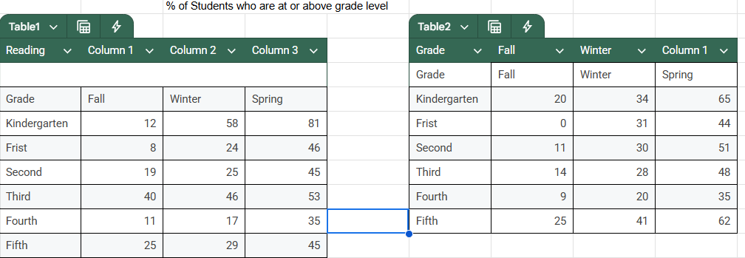

  - Academic Awards were held on Friday at the last DSES Morning Assembly
    - Attendance Award winners were announced and bikes were given from the Al E. Orton Lodge #628 F & AM Masonic Lodge
    - Students received All As and All As/Bs awards as well as classroom academic awards.
- KSA Testing is finished - Best effort from our students than we have seen in a long time!!

- Upcoming Events:
  - Tuesday, May 20 - FIELD DAY and 5:30 PM PK Graduation in big gym
  - Wednesday, May 21 - Field Day rain date and 5th grade to the Movies
  - Thursday, May 22, 2025 - Field Trip Grades ¾ to Maggie’s Jungle Golf
  - Friday, May 23, 2025 - 2:30-2:45: 3-4-5 Good Faith Effort waterslide

