CONSENT ITEM G
May 19, 2025
OLDHAM COUNTY BOARD OF EDUCATION
CONCERN
Consider Approval of Kerri Alexander as Board Treasurer for 25-26 SY beginning July 1st, 2025 and beyond as part of the CFO’s job description.
DISCUSSION
Dr. Thomas Shelton remained Board Treasurer to provide oversight and guidance as Ms. Alexander acclimated to her new role.
The Superintendent recommends the Board appoint Kerri Alexander as Board Treasurer for the 25-26 SY beginning July 1st, 2025 and beyond as part of the CFO’s job description.
RECOMMENDATION
Approve the appointment of Kerri Alexander as Board Treasurer for the 25-26 SY beginning July 1st, 2025 and beyond as presented.

On a motion by _______________, seconded by _______________, the Board approved the appointment of Kerri Alexander as Board Treasurer for the 25-26 SY beginning July 1st, 2025 and beyond as presented. ( , )


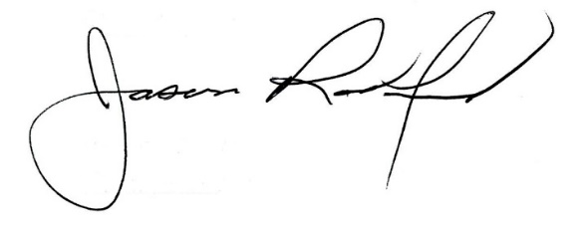

Carly Clem, Board Chair Dr. Jason Radford, Superintendent/Secretary

