CONSENT ITEM F
May 19, 2025
OLDHAM COUNTY BOARD OF EDUCATION
CONCERN
Consider approval of the OCS Preschool FY26 calendar.
DISCUSSION
The calendar is attached for your convenience and review prior to the meeting
RECOMMENDATION
Approve the proposed preschool calendar for FY26.


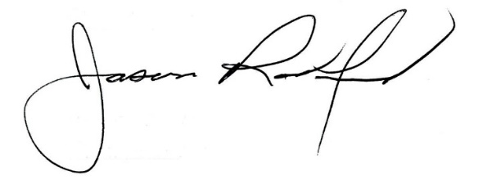
On a motion by _______________, seconded by _______________, the Board approved the FY26 Preschool Calendar. ( , )

Carly Clem, Board Chair Dr. Jason Radford, Superintendent/Secretary

