CONSENT ITEM A
May 19, 2025
OLDHAM COUNTY BOARD OF EDUCATION
CONCERN
Consider Approval of Field Trips Requesting Overnight Stay & Field Trips Requesting Use of Common Carrier.
DISCUSSION
The following are field trips requesting overnight stay and trips requesting use of a common carrier:
SCHOOL | GROUP | LOCATION/DATE | JUSTIFICATION | INSTR. DAYS LOST
OCHS | Dance Team | UL  July 14-17, 2025 | Overnight: Training Camp  Parent | 0
Overnight: Gateway Classic
Charter Bus
Overnight: Camp
Car Rental
Overnight: HOSA Training
Parents
Overnight: Tournament
Charter
Overnight: Tournament
Board Vehicle
Overnight: Tournament
Parent
Overnight: Tournament
Parent
Overnight: Tournament
Charter
Overnight: Camp
Bus
Approve the field trips as attached and described above, pursuant to the condition that students not traveling on school buses, with their parents, or with a Board employee whose insurance carrier has named OCBE as an additional named insured, will be transported to and from their destination on an approved charter bus(es) and school(s) shall obtain written evidence of liability.

Motion Passed: Motion by _______________, seconded by _______________, the Board gave approval of the field trips as attached and described above, pursuant to the condition that students not traveling on school buses, with their parents, or with a Board employee whose insurance carrier has named OCBE as an additional named insured, will be transported to and from their destination on an approved charter bus(es) and school(s) shall obtain written evidence of liability. ( , )
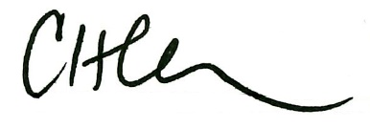
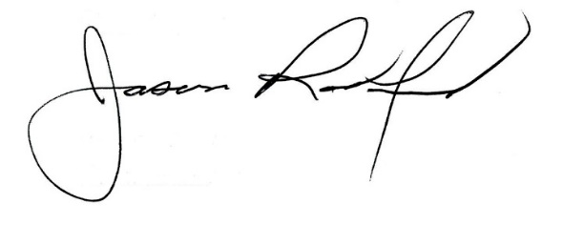

Carly Clem, Board Chair Jason Radford, Superintendent/Secretary

