MINUTES
May 19, 2025
OLDHAM COUNTY BOARD OF EDUCATION

CONCERN
Consider Approval of Meeting Minutes.

DISCUSSION
The draft minutes of the April 28, 2025 – Regular Meeting are available for review and approval.

RECOMMENDATION
Approve the minutes of the following meetings as presented.

April 28, 2025 – Regular Meeting
(1) Carly Clem, Chairperson, (2) Allison Sheffer, Board Vice Chairman; (3) Suzanne Hundley, Board Member (4) Joe Dennis, Board Member (5) Adam Springer, Board Member, and Dr. Jason Radford, Superintendent and Secretary to the Board were present.

On a motion by _______________, seconded by _______________, the Board approved the minutes of the April 28, 2025 – Regular Meeting. ( , )

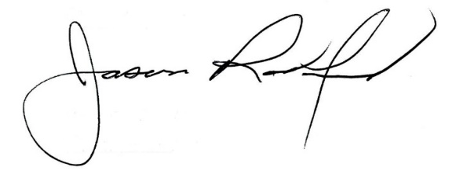
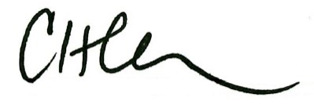

Carly Clem, Board Chair Jason Radford, Superintendent/Secretary

