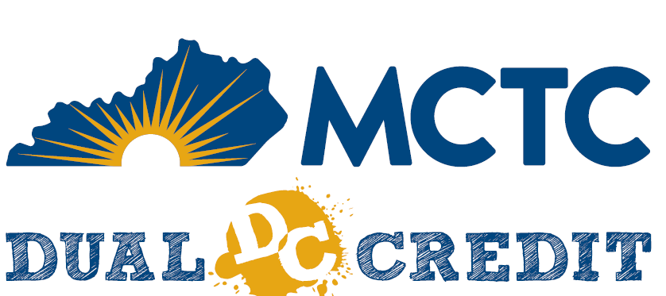

This section of the Memorandum of Understanding (MOU) outlines the roles and responsibilities for the Guidance Counselors of our local districts. Maysville Community and Technical College appreciates your partnership to better serve your students enrolled in the MCTC Dual Credit program.
Local District Roles and Responsibilities:
- Review high school rosters and respond with any discrepancies within a timely manner.
- Assist students in completing their KHEAA scholarship preferences.
- Assist students and communicate with KHEAA regarding scholarship adjustments.
- Monitor Starfish notifications and inform students within a timely manner.
- Review student balances within a timely manner.
- Assist students with withdrawals.
- Collaborating with the Dual Credit coordinator to set a date/time for registration visits.
- Assist students with applying to MCTC and completing the DualEnroll process as needed for registration.
- Collaborate with the MCTC Dual Credit coordinator to complete necessary tasks prior to the registration event.
- Assist students & MCTC representatives at the registration event.
- Inform the Office of Dual Credit when there is an instructor change and work with the Office of Academic Services for credentialing a new instructor.

