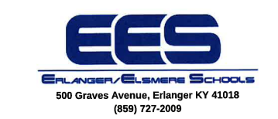
Agreement for Technology Services
This Service Agreement is an agreement between the Northern Kentucky Cooperative for Educational Services (NKCES), 5516 East Alexandria Pike, Cold Spring, KY 41076, and the Erlanger-Elsmere Independent (EES), 500 Graves Avenue, Erlanger, KY 41018.

Erlanger-Elsmere Independent Schools agrees to make a School Technology Assistant available on-site for seventy-two (72) days between July 1, 2025, and June 30, 2026, and have the CIO, District Network Manager, or their designee available for consultation to satisfy the following:

- Support of hardware/software throughout the building
- Support of the email system
- Support of internet (wired and wireless)
- Maintenance of the current firewall for the Regional School Program
- Addition of new employees to the network
- Scheduling and performing system updates
- Emergency support
- Additional troubleshooting that may be needed as agreed upon.

TERMS OF SERVICE CONTRACT
The term of this agreement shall automatically renew each year. Either party can discontinue the agreement 30 days prior to the end of the school year. NKCES agrees to pay the Erlanger-Elsmere Independent School District a total of twenty-one thousand six hundred dollars ($21,600) for services. Payments shall be made in equal monthly amounts of one thousand eight hundred dollars ($1800).

______________________________________________________ _________________
Superintendent – Erlanger-Elsmere Independent School District Date

______________________________________________________ _________________
Executive Director – NKCES Date

