ACTION ITEM B
April 28, 2025
OLDHAM COUNTY BOARD OF EDUCATION
CONCERN
2025-26 salary schedules
DISCUSSION
Typically, salary schedules are presented in the June board meeting, but we want to start presenting salary schedules in the April board meeting so that we can use them to firmly and legally give potential new hires their earnings during the interview process and take any uncertainty during the hiring process.
The salary schedule you are approving tonight is the creation of what was approved during our February board meeting about recruitment and retention.
- 5% increase for all salaried employees
- $2 increase for hourly employees
- 4-year bump of the certified teacher salary schedule as discussed and those attached to it
- Extension to 33 years for all current employee salary schedules, which did cause some adjustments. We needed to adjust several salary schedules so that a reasonable average step increase occurred. Several 2024-25 salary schedules stop at year 23 or year 27 and when we extended, we had to account for these adjustments.
- Old salary schedules were awarded 5% and $2 but not the 33-year extension.
RECOMMENDATION
Approve the 2025 – 2026 salary schedules as presented

On a motion by _______________, seconded by _______________, the Board approved the 2025 – 2026 salary schedules as presented

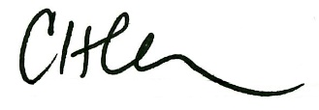

Carly Clem, Board Chair Dr. Jason Radford, Superintendent/Secretary

