ACTION ITEM A
April 28, 2025
OLDHAM COUNTY BOARD OF EDUCATION
CONCERN
Consider approval of Policy Revisions.
DISCUSSION
Consider the approval of policy revisions listed below.
NUMBER | NAME OF POLICY | REASON FOR AMENDMENT/ADDITION
Policy –2nd read
CC03.273 | Personnel | Addition of language for Unused Sick Days payout for Classified Staff.  This was not included in the original policy approved in May 2024.

RECOMMENDATION
Approve the revisions to policy.

On a motion by _______________, seconded by _______________, the Board approved the policy revisions as presented

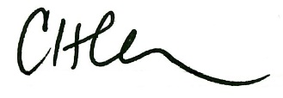

Carly Clem, Board Chair Dr. Jason Radford, Superintendent/Secretary

