CONSENT ITEM K
April 28, 2025
OLDHAM COUNTY BOARD OF EDUCATION
CONCERN
Consider approval of an option for enrichment programs to request a Kentucky Kingdom pass for students during the summer so that they can go weekly to the park.
DISCUSSION
One of the more cost-effective ways to take field trips is for families to purchase a Kentucky Kingdom pass at a negotiated price and the enrichment program to take students weekly. Some of our enrichment programs have requested the ability to ask families to purchase the pass.
OLDHAM COUNTY ENRICHMENT SERVICES, HOURS OF OPERATION, AND TUITION
SERVICES | HOURS OF OPERATION | TUITION
After School (Full-time)  Three or more days a week | 2:15 - 6:00 | - $90/week for first child  - $65/week per additional child
After School (Part-time)  One or two days a week | 2:15 - 6:00 | - $30/day for first child  - $25/day per additional child
Full Days during the school year  Non-work days, or Snow Days* | Non-work days- 7:00 - 5:30  Snow Days- 8:00-5:00 | - $50/day for first child  - $40/day per additional child
Seasonal Breaks  Fall Break, Winter Break, and Spring Break  *Field Trip costs are not included in weekly/daily rates* | 7:00 - 5:30 | - $160/week for first child  - $120/week per additional child  OR  - $50/day for first child  - $40/day per additional child
Summer Program (Full-time)  Three or more days a week | 7:00 - 5:30 | - $160/week for first child  - $120/week per additional child
Summer Program (Part-time)  One or two days a week | 7:00 - 5:30 | - $50/day for first child  - $40/day per additional child
LATE PICK-UP FEE: A charge of $1.00 per minute will be imposed after 6:00 PM (5:00 PM on Snow Days) and due immediately upon pick-up.
ANNUAL REGISTRATION FEE: $40.00 per child. Non-refundable; due at the beginning of each school year
SUMMER ENRICHMENT FEES: To be determined each summer by Youth Enrichment Programs
Non-refundable; due upon enrollment for the Summer program. Not to exceed $300.
**Some programs may request a Kentucky Kingdom pass due to the frequency of field trips to this location.
RECOMMENDATION
Approve the option for enrichment centers to request a Kentucky Kingdom pass at a negotiated price.

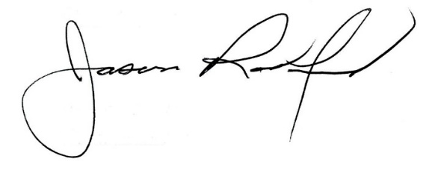
On a motion by _______________, seconded by _______________, the Board option for enrichment centers to request a Kentucky Kingdom pass at a negotiated price. ( , )


Carly Clem, Board Chair Dr. Jason Radford, Superintendent/Secretary

