CONSENT ITEM J2
April 28, 2025
OLDHAM COUNTY BOARD OF EDUCATION
CONCERN
Elimination of the position cafeteria monitor funded through school nutrition.
DISCUSSION
For the past three years we have been in a period of transition concerning the cafeteria monitor position. The position of cafeteria monitor should be under the direction of custodial services and funded through custodial services not food service. When we were informed several years back of needing to make this change, we started to transition all schools towards a 4-hour swing shift custodian position instead of cafeteria monitor. This allowed for custodial help in the cafeteria and custodial help throughout the school during the school year. Currently 15 of our 19 schools have swing shift custodians not cafeteria monitors.
Due to school nutrition previously being on a mandatory spend down plan for the past several years, we said we would allow cafeteria monitors to stay in these positions until they resigned or retired. However, starting next year the school nutrition department is no longer on a mandatory spend-down plan. We are going to have a reduction in funding at the same time as a reduction in reimbursement for our CEP schools. This reduction means we will no longer be able to provide CEP status to three schools next year.
It is now time to eliminate the remaining four cafeteria monitors positions and transition them all to custodial swing swift workers if the employee would like. This will change the funding source and number of hours. The swing shift custodian is already allotted in the budget for all schools.
RECOMMENDATION
Approve the elimination of the cafeteria monitor position and remove the job description from the Administrative Regulations.

On a motion by _______________, seconded by _______________, the Board approved elimination of the cafeteria monitor position and remove the job description from the Administrative Regulations. ( , )

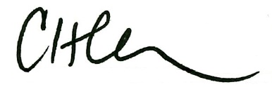
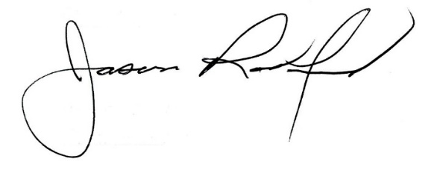

Carly Clem, Board Chair Dr. Jason Radford, Superintendent/Secretary

