CONSENT ITEM J1
April 28, 2025

OLDHAM COUNTY BOARD OF EDUCATION
CONCERN
Elimination of Administrative Regulation 1040.07 - Billing Specialist.
DISCUSSION
During the March board meeting, the board approved the increase of duties and pay for the Assistant Benefits Coordinator. In doing so they asked that we eliminate the position 1040.07 - Billing Specialist.
RECOMMENDATION
Approve the elimination of Administrative Regulation 1040.07 - Billing Specialist.

On a motion by _______________, seconded by _______________, the Board approved elimination of Administrative Regulation 1040.07 - Billing Specialist. ( , )


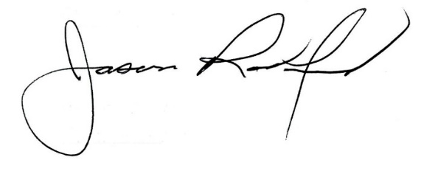

Carly Clem, Board Chair Dr. Jason Radford, Superintendent/Secretary

