CONSENT ITEM I
April 28, 2025
OLDHAM COUNTY BOARD OF EDUCATION
CONCERN
Consider Approval of Planning & Development Agency Letter for the following projects:
- Bishop Place APTs
- Parkside Estates
- Summit Creek Apts
- Pine Grove Subdivision
DISCUSSION
As part of the Oldham County Planning and Development capacity planning process, developers must submit a request for an agency letter from the Oldham County Board of Education regarding school capacity for any planned developments. Letter requests must be submitted to the Board 15 days prior to the date of the monthly Board meeting at which approval is sought.
The agency letter is reviewed by Superintendent Radford after an analysis of existing and planned school capacity for the affected schools and projections of enrollment for the affected schools, or if there will be available capacity in either of the following two academic years. If an agency letter is denied based upon a lack of capacity for all three years, the OCBE may consider mitigating factors opposed by the developer.
Including the Board of Education in the Planning and Development approval process is designed to ensure that the Oldham County Schools will be able to accommodate future growth in Oldham County. Letters submitted to the Board for approval are those for which it has been determined that existing and planned school capacity will be adequate for the proposed development.
RECOMMENDATION
Approve the agency letter as submitted for the projects listed below:
- Bishop Place Apts
- Parkside Estates
- Summit Creek Apts
- Pine Grove Subdivision

On a motion by _______________, seconded by _______________, the Board approved the Planning & Development Agency Letter for the projects as presented. ( , )


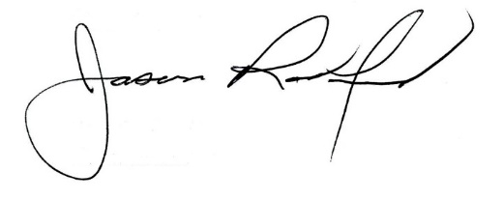

Carly Clem, Board Chair Jason Radford, Superintendent/Secretary

