CONSENT ITEM H
April 28, 2025
OLDHAM COUNTY BOARD OF EDUCATION
CONCERN
Consider FY26 pay dates for Certified, Classified and Substitute staff.
DISCUSSION
For the FY26 school year, payroll for all employees will continue to be on a semi-monthly basis, with 24 pay dates, on the 15th and 30th of each month. When these dates fall on weekends or holidays, the pay date will be the last working day prior to the 15th or 30th.
RECOMMENDATION
Adopt pay dates per attached listings for the FY26 school year.

On a motion by _______________, seconded by _______________, the Board approved the pay dates as presented for the FY26 school year. ( , )

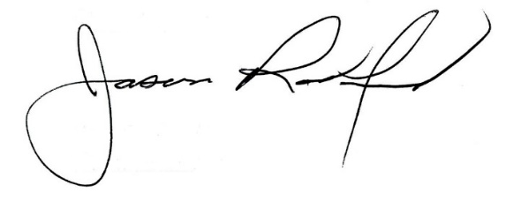
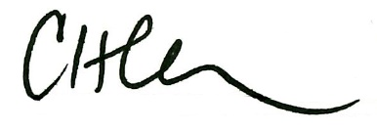

Carly Clem, Board Chair Dr. Jason Radford, Superintendent/Secretary

